**CMPE 282 CLOUD SERVICES**

**HOMEWORK - 2**

**CISCO APIC 3.0 WITH UCS DIRECTOR 6.5**

**TEAM SPARTANS**

MUKESH RANJAN SAHAY

THIRUMALAI NAMBI DOSS PALANI

MUTHU KUMAR SUKUMARAN

SUDHA AMARNATH

## Scenarios

This assignment includes the following scenarios:

* **Scenario 1:** Tenant Onboarding
* **Scenario 2:** Deploy a Simple 3-Tier Application Container with L3Out
* **Scenario 3:** Deploy an Application Container with L4-L7 Services (ASAv)
* **Scenario 4:** Deploy a 3-Tier Application with L4-L7 Services (Load Balancer)
* **Scenario 5:** Deploy a 3-Tier Application with a Physical Server (Emulated)

**Cisco D Cloud Assignment Link**

<https://dcloud2-rtp.cisco.com/content/demo/367927>

**UCS Director Catalogs**

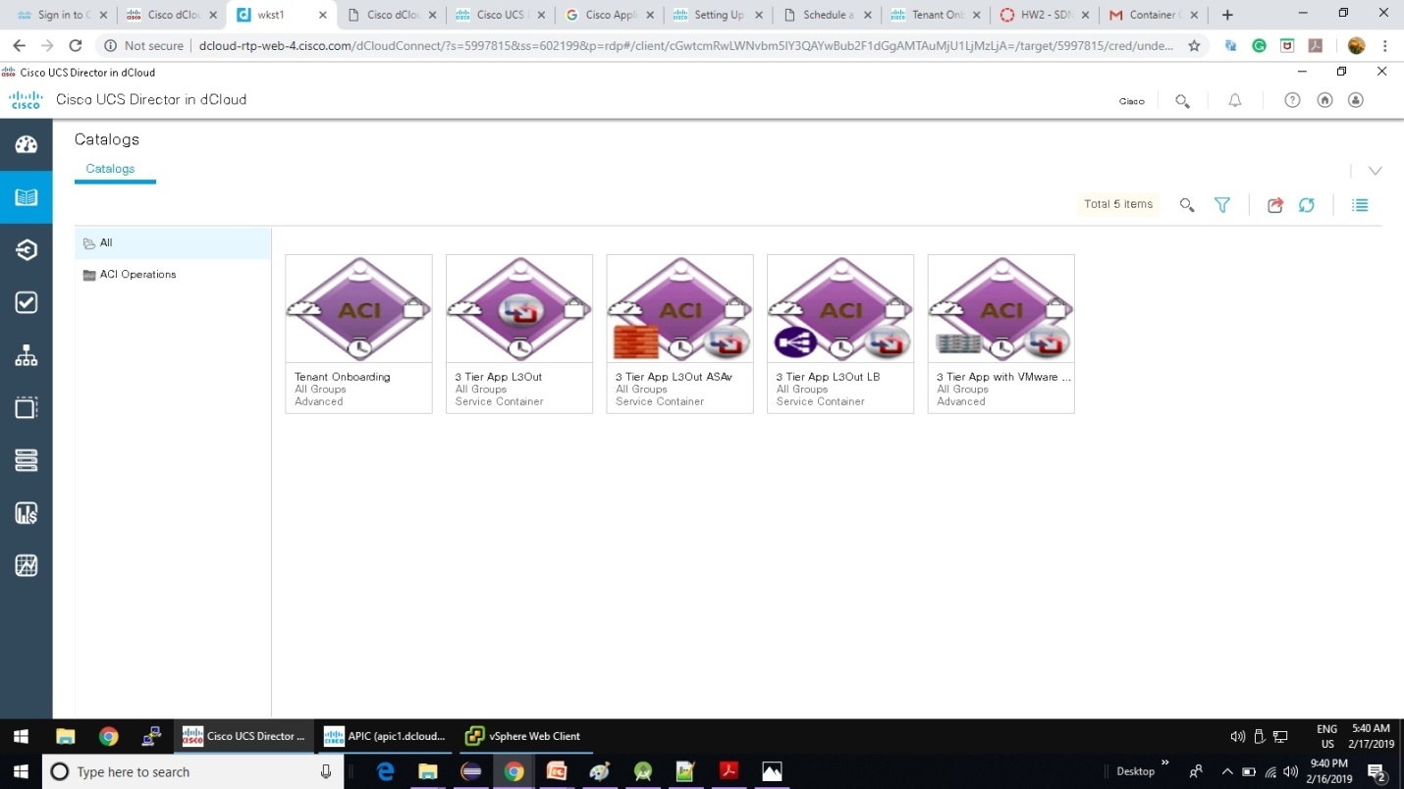

**D cloud - Topology**

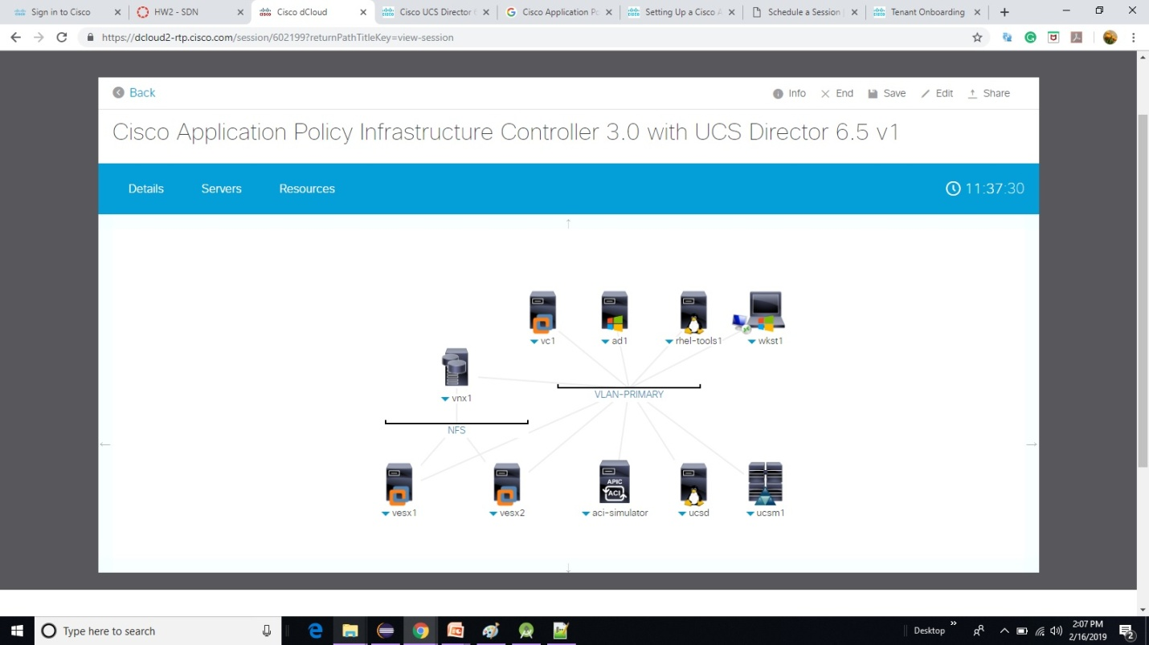

**Scenario 1:** Tenant Onboarding - Workflow

• Creates a new security group and user in UCS Director for the Tenant

• Interfaces with Cisco APIC and creates the tenant specified in the workflow wizard, and creates the corresponding tenant in UCS Director.

• Identify Virtual Compute Resources: Identifies the compute & storage resources that are available to the tenant in VMware, and creates the VMware resource pool.

• Creates a private network for the tenant in APIC (VRF) and associates the identified infrastructure resources to the UCS Director tenant

• Sets up the Tenant for UCS Director Application Container Services.

**Scenario 1:** Tenant Onboarding – Service Request

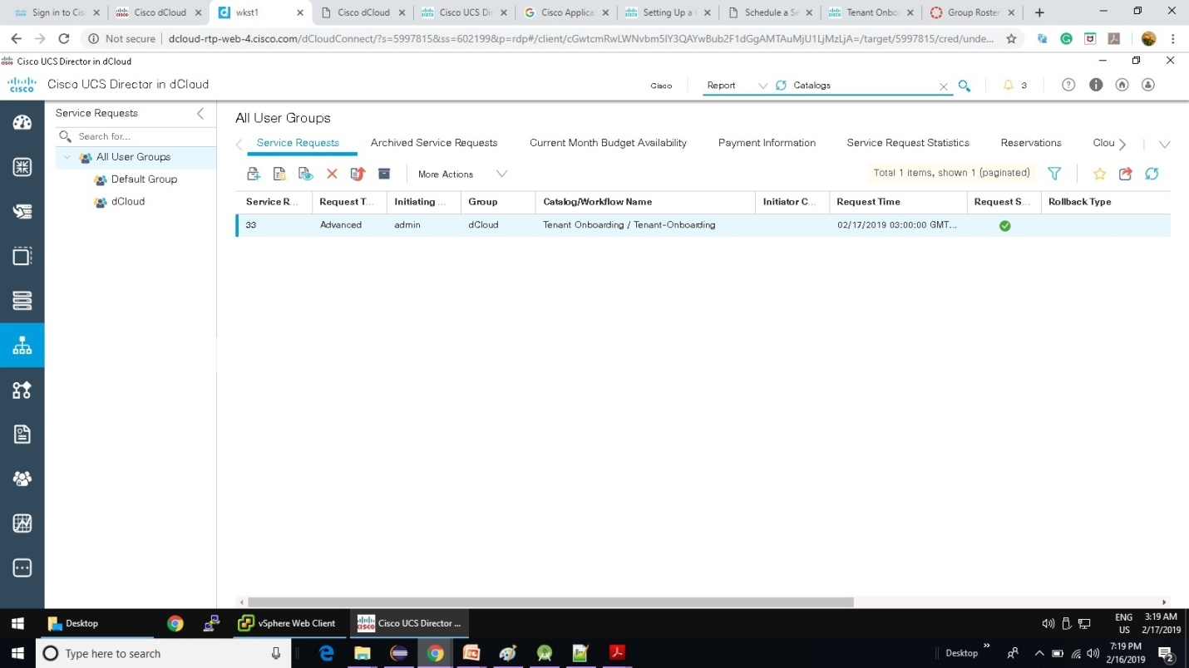

**Scenario 1:** Tenant Onboarding – Service Request Creation

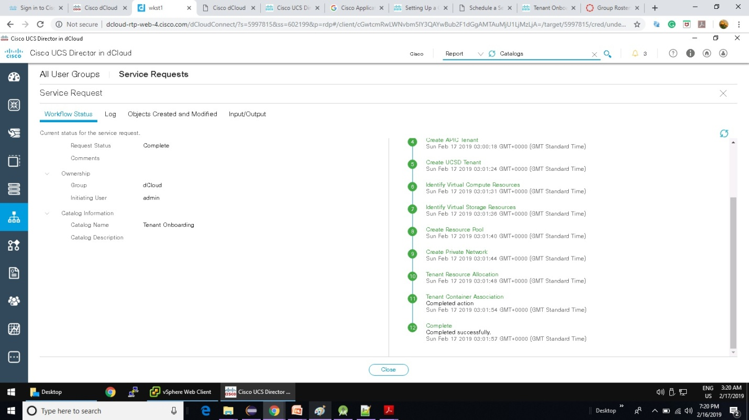

**Scenario 1:** Tenant Onboarding – vSphere WebClient BlueSky tenant creation

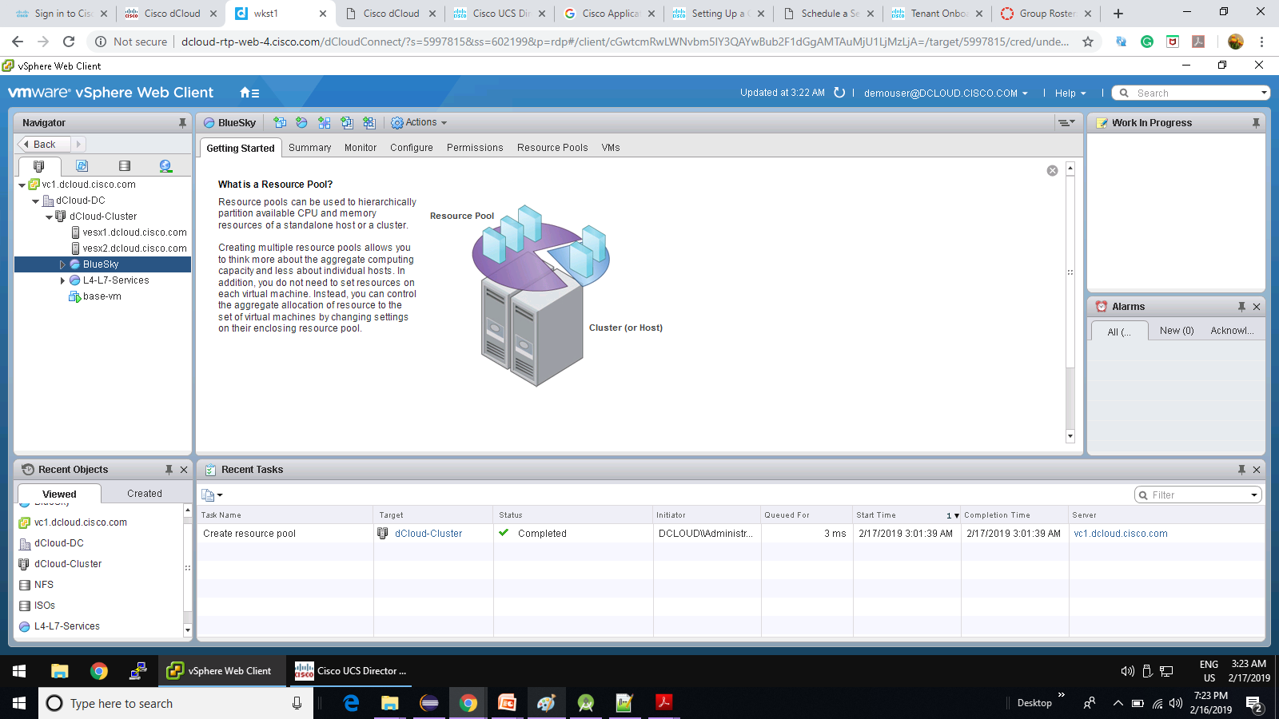

**Scenario 1:** Tenant Onboarding – BlueSky_PrivateNetwork creation in APIC Client

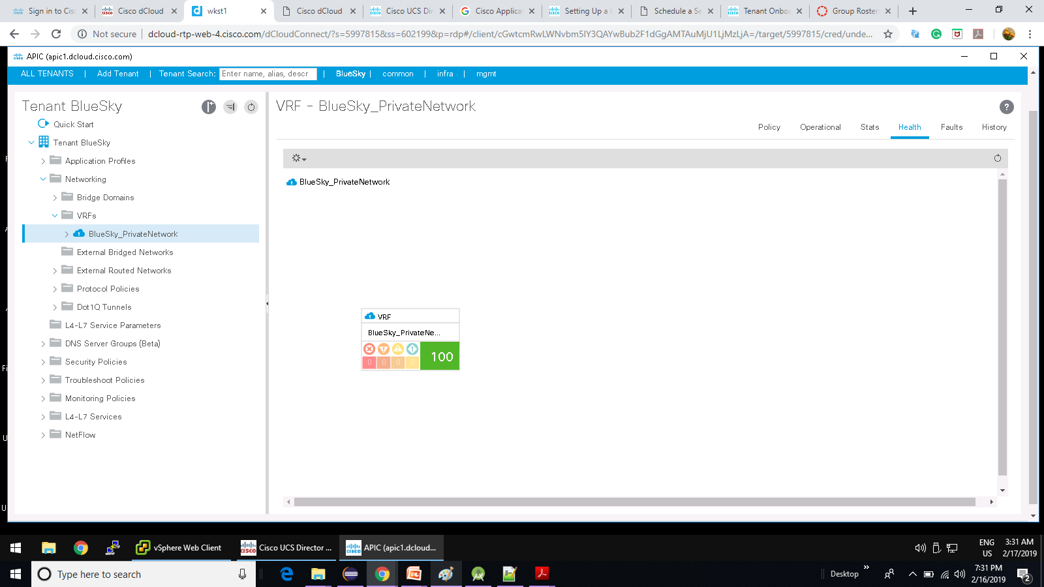

**Scenario 1:** Tenant Onboarding – TenantResourceGroup in UCS Director

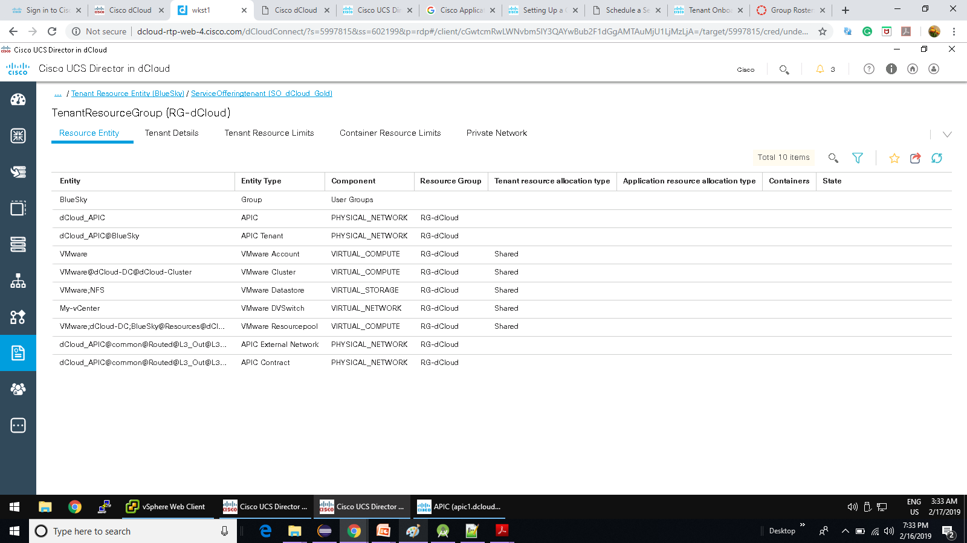

**Scenario 2:** Deploy a Simple 3-Tier Application Container with L3Out

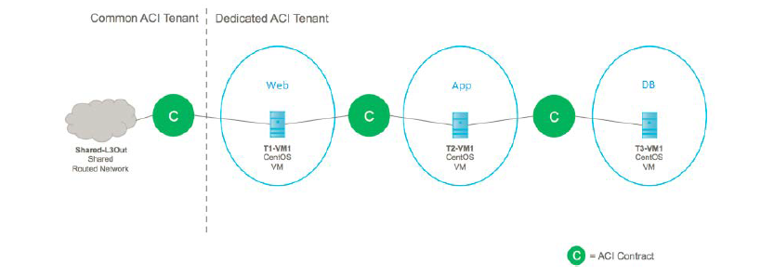

**Scenario 2:** Deploy a Simple 3-Tier Application Container with L3Out – Workflow

The 3 Tier App L3Out workflow performs the following steps:

• Creates a container in UCS Director and allocates resources.

• Creates the APIC objects – Application profile, Private network, Bridge Domains and Contracts. New Port Profiles are automatically propagated to VMware Distributed Switch..

• Creates the VM for each application in VMware, connecting them to the relevant EPGs for their tier.

• Sends confirmation email to Tenant Admin Email Address (from Scenario 1).

**Scenario 2:** Deploy a Simple 3-Tier Application Container with L3Out – Service Creation

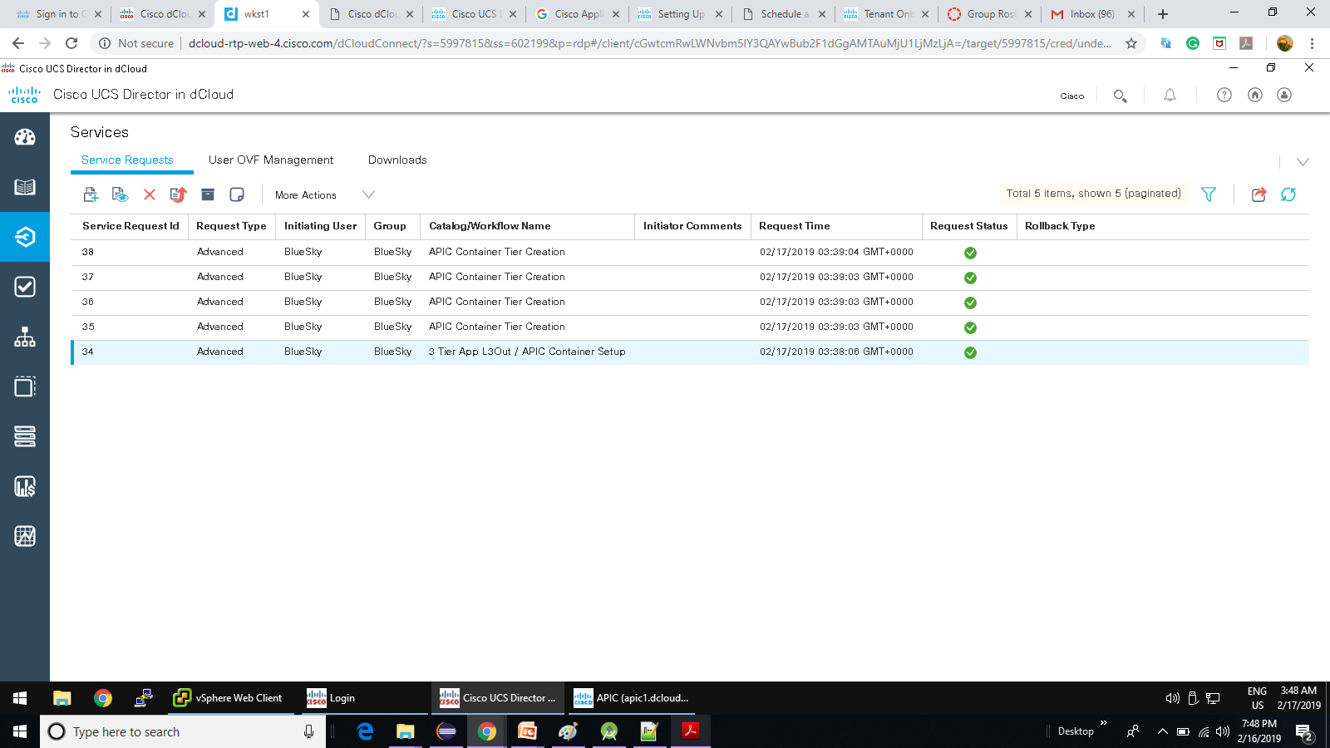

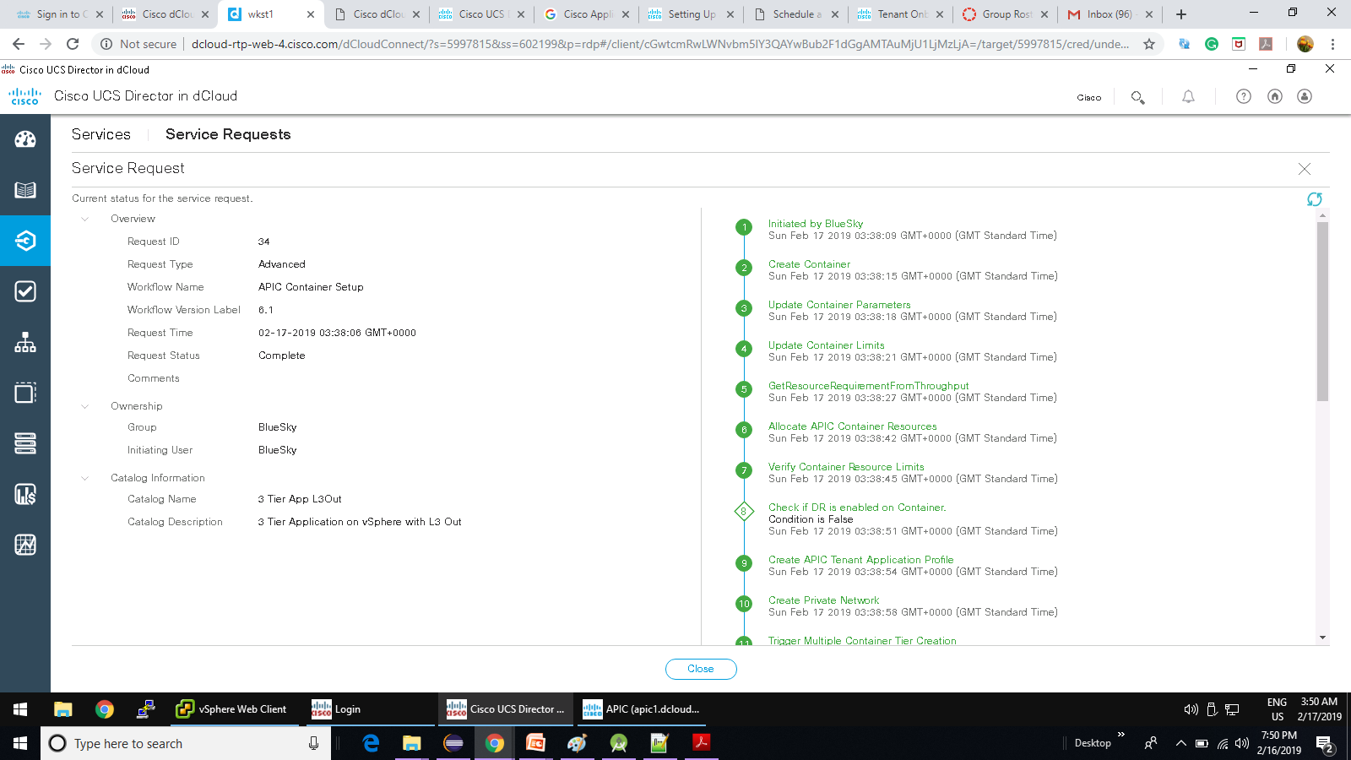

**Scenario 2:** Deploy a Simple 3-Tier Application Container with L3Out – BasicApp Application profile Topology

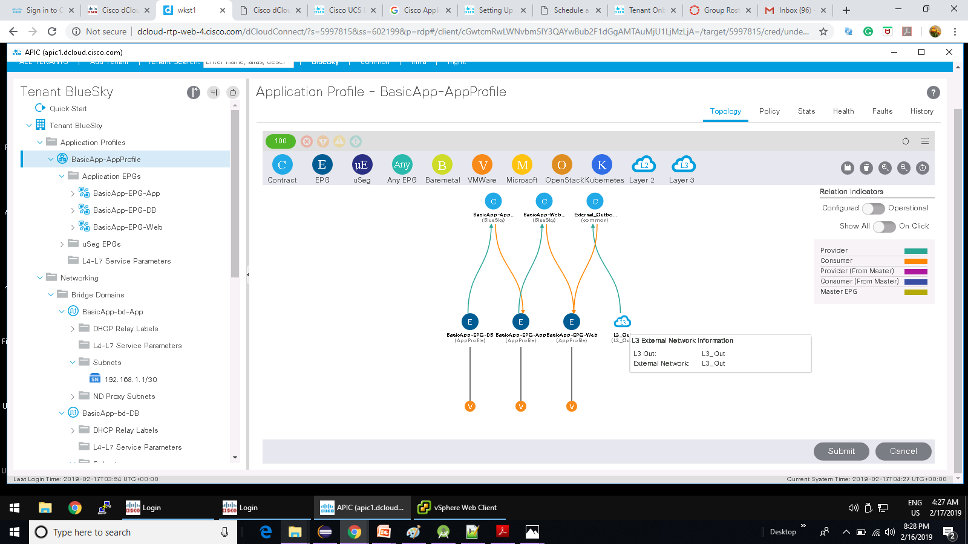

**Scenario 2:** Deploy a Simple 3-Tier Application Container with L3Out – vSphere Web Client BasicApp Creation

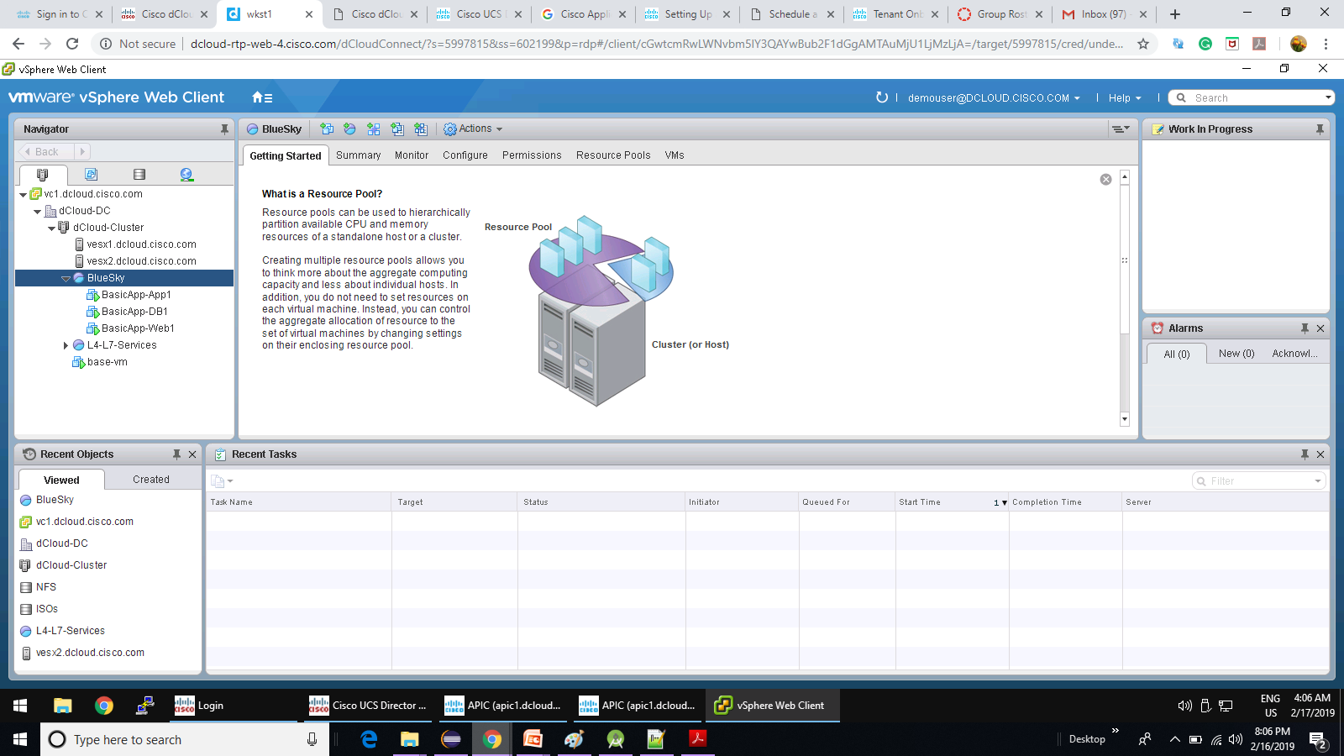

**Scenario 2:** Deploy a Simple 3-Tier Application Container with L3Out – VM Hardware profile

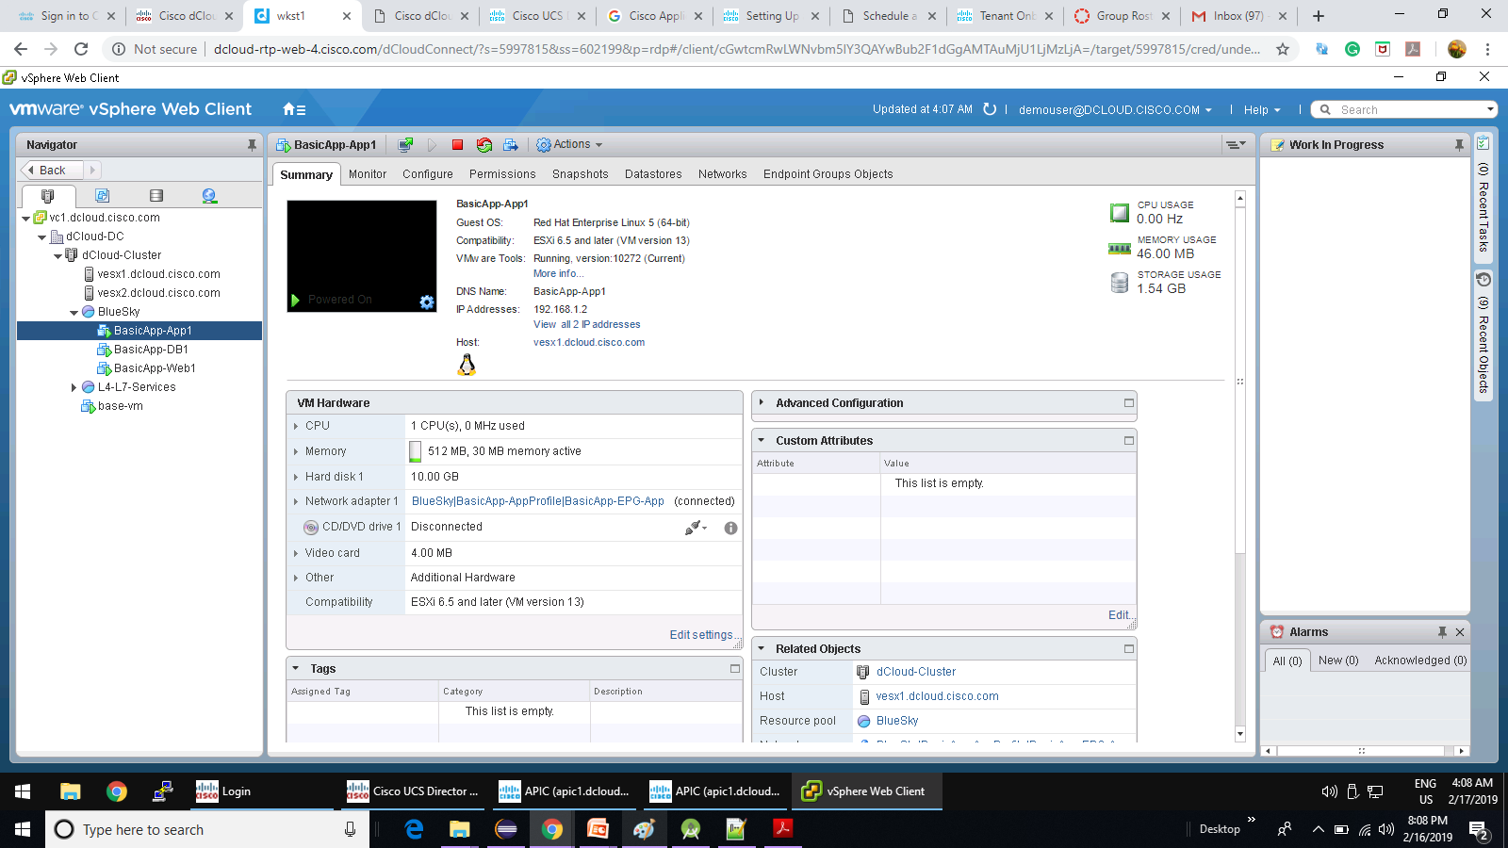

**Scenario 2:** Deploy a Simple 3-Tier Application Container with L3Out – APIC Bridged Domain

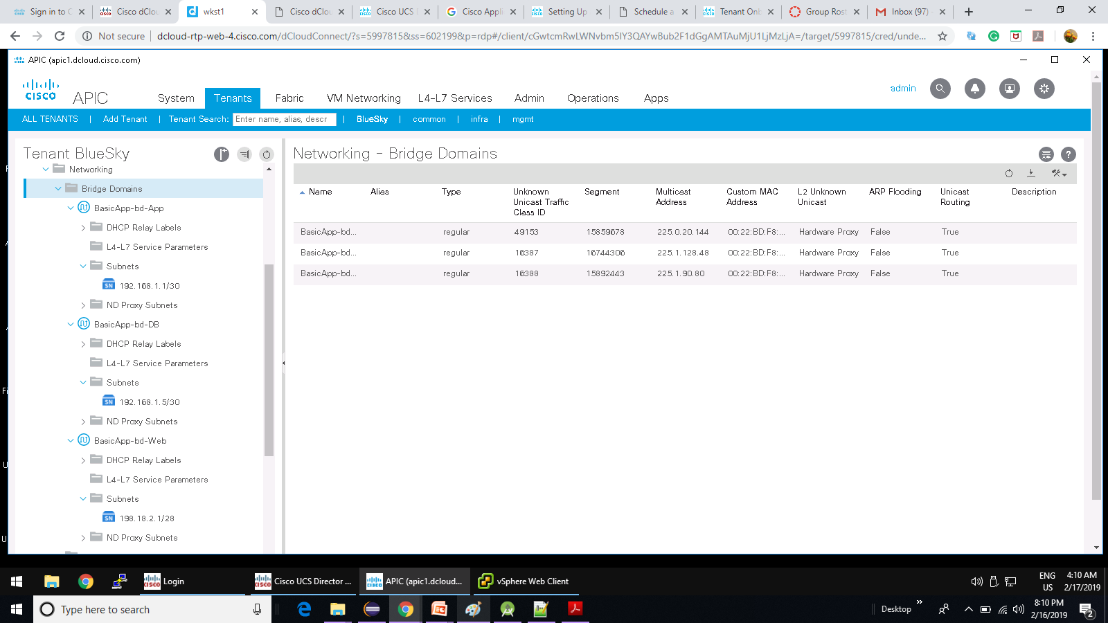

**Scenario 2:** Deploy a Simple 3-Tier Application Container with L3Out – APIC Application BasicApp AppProfile

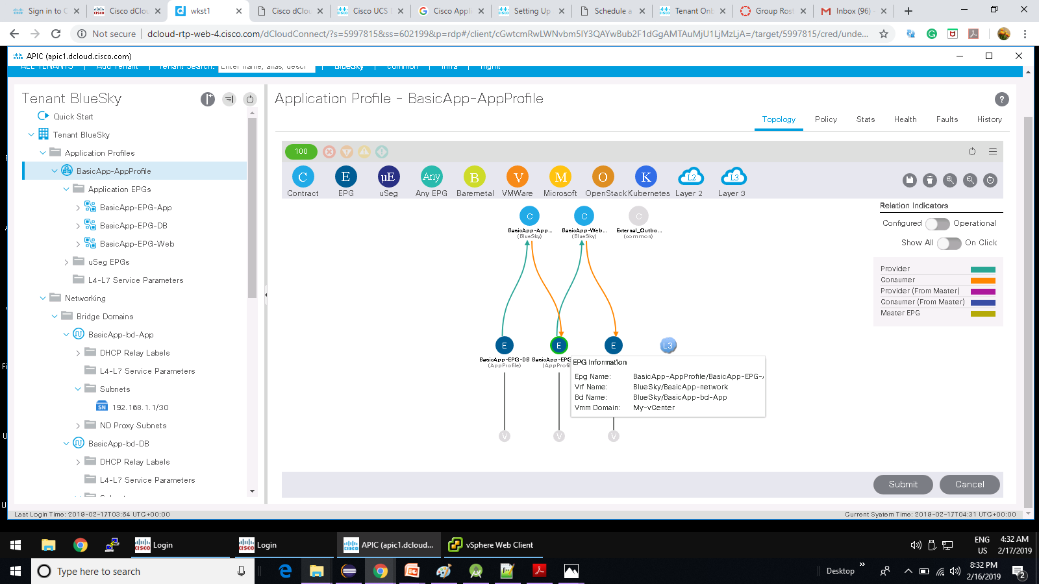

**Scenario 2:** Deploy a Simple 3-Tier Application Container with L3Out – UCS Director Virtual Resource for BasicApp

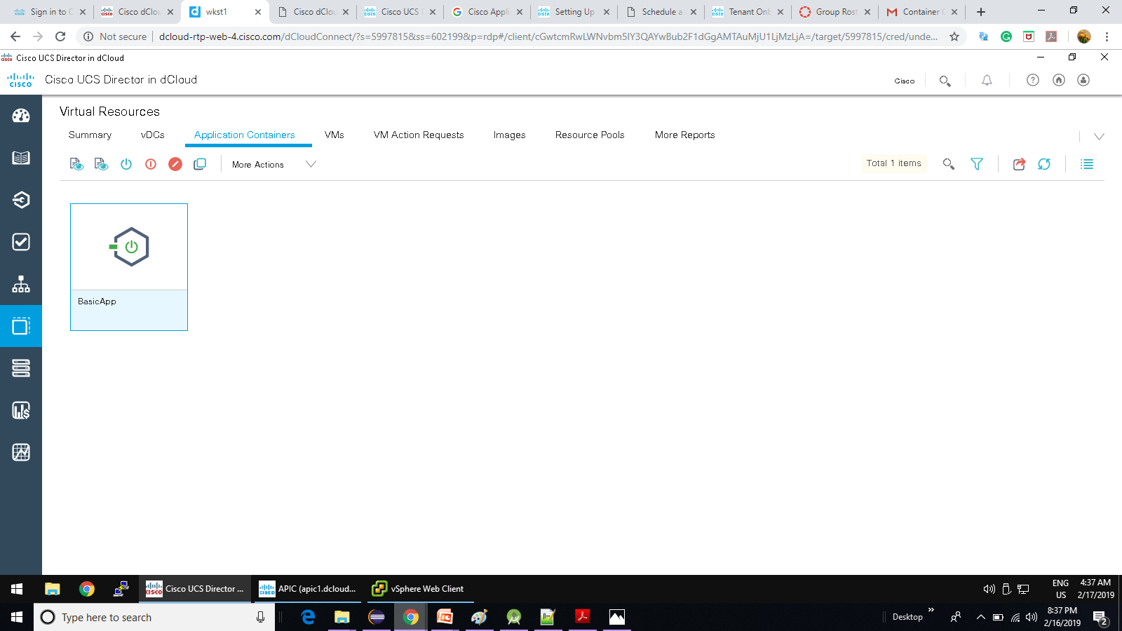

**Scenario 2:** Deploy a Simple 3-Tier Application Container with L3Out – Container Created Email

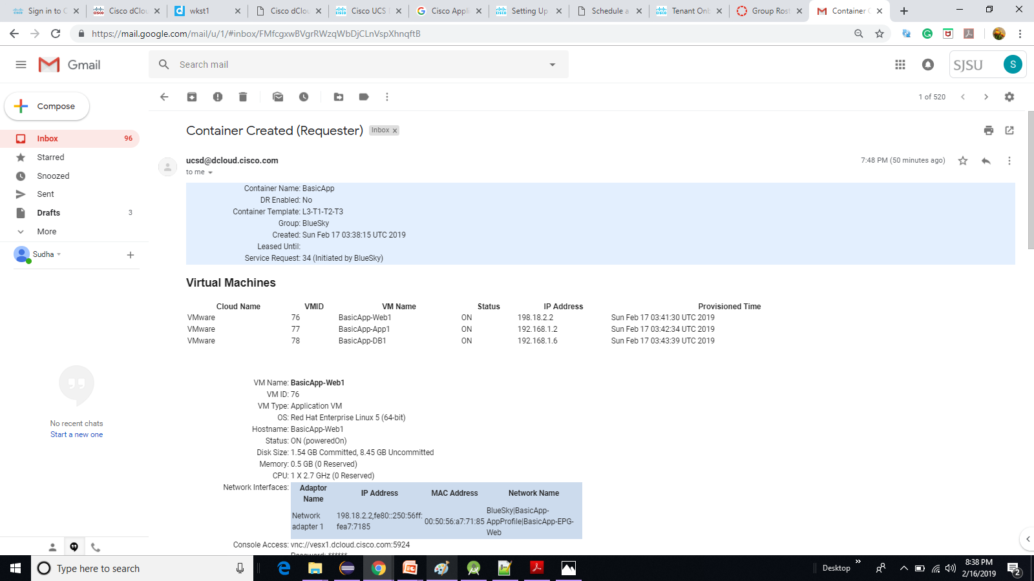

**Scenario 3:** Deploy an Application Container with L4-L7 Services (ASAv)

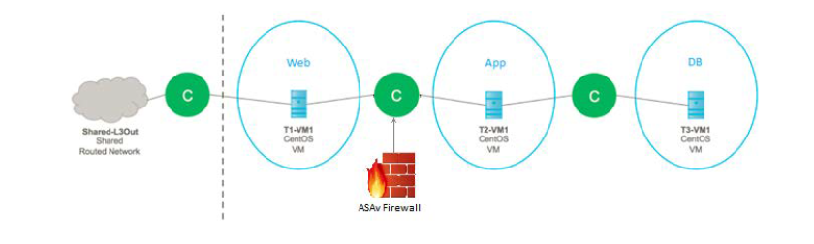

**Scenario 3:** Deploy an Application Container with L4-L7 Services (ASAv) – Workflow

The 3 Tier App L3Out ASAv workflow performs the following steps:

• Creates a container in UCS Director and allocates resources.

• Creates the APIC objects – Application Profile, private network, Bridge Domains and Contracts. New Port Profiles are automatically propagated to the VMware Distributed Switch.

• Creates the VM for each application in VMware, connecting each to the relevant Port Profile for its tier.

• Creates a child workflow that deploys a new ASAv virtual appliance to VMware.

• Another child workflow sets up the L4-L7 Service Graph configuration (ASAv)

• Sends confirmation email to Tenant Admin Email Address (from Scenario 1).

**Scenario 3:** Deploy an Application Container with L4-L7 Services (ASAv) – Service Creation

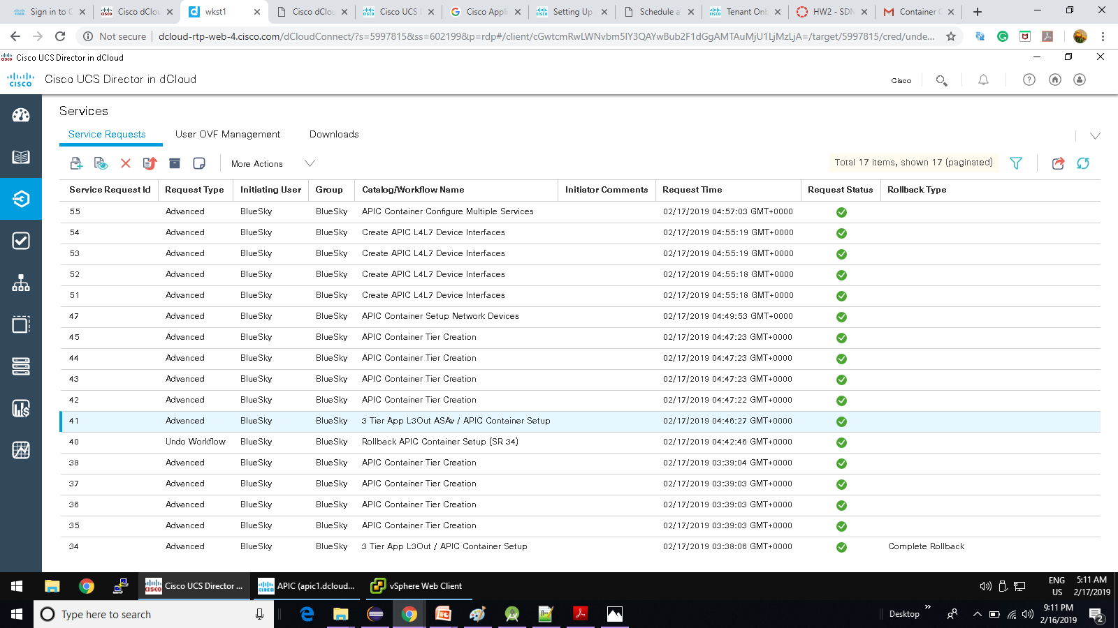

**Scenario 3:** Deploy an Application Container with L4-L7 Services (ASAv) – CoolApp Application Profile

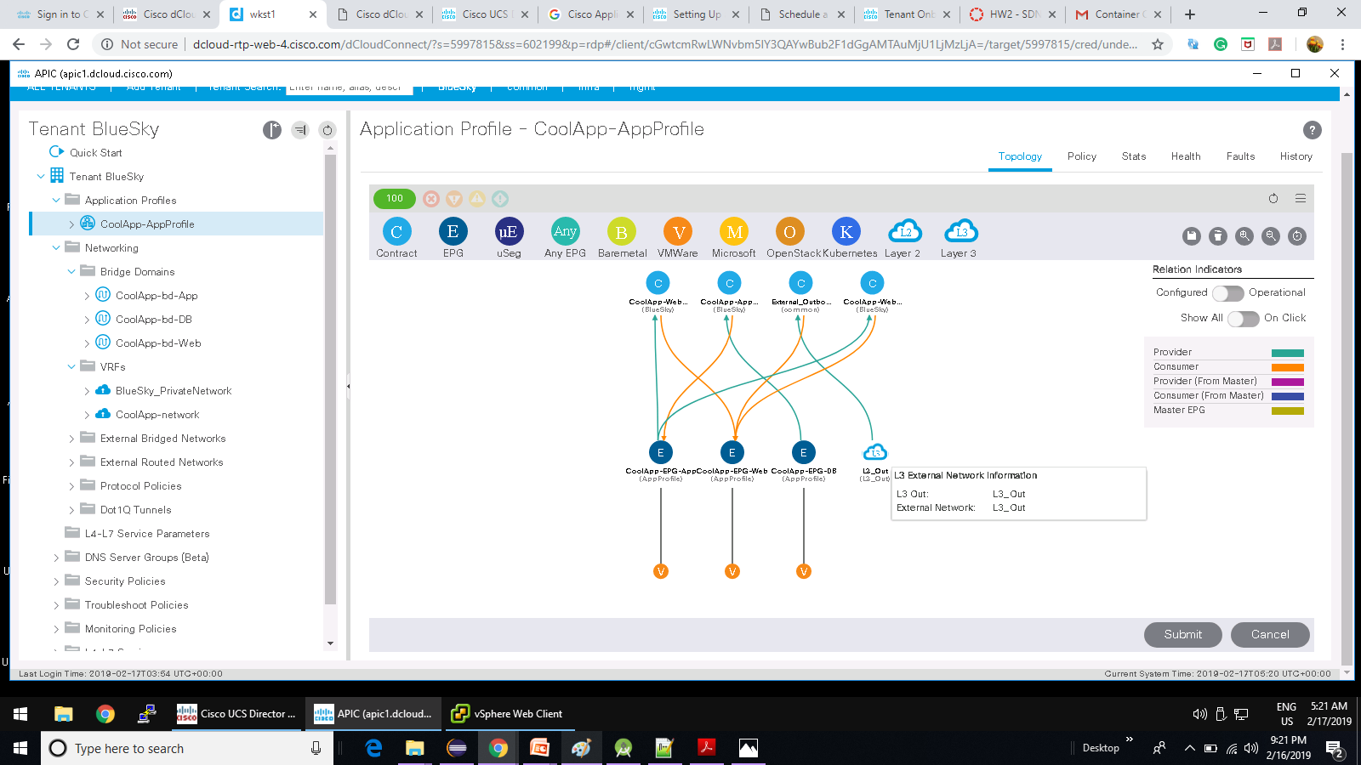

**Scenario 3:** Deploy an Application Container with L4-L7 Services (ASAv) – CoolApp Application Profile for L4-L7 ASAv Service Graph

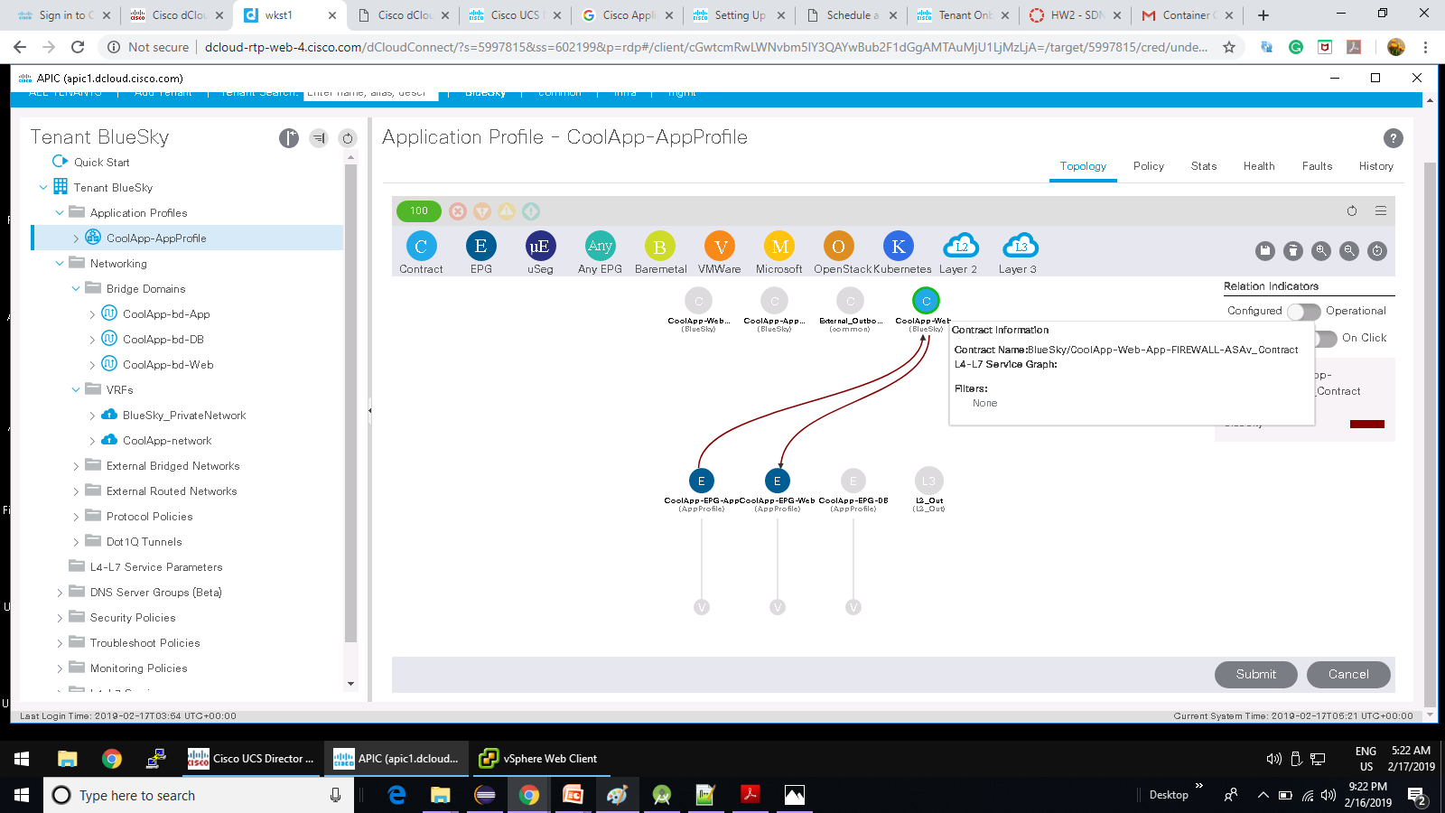

**Scenario 3:** Deploy an Application Container with L4-L7 Services (ASAv) – L4-L7 ASAv Service Graph Template

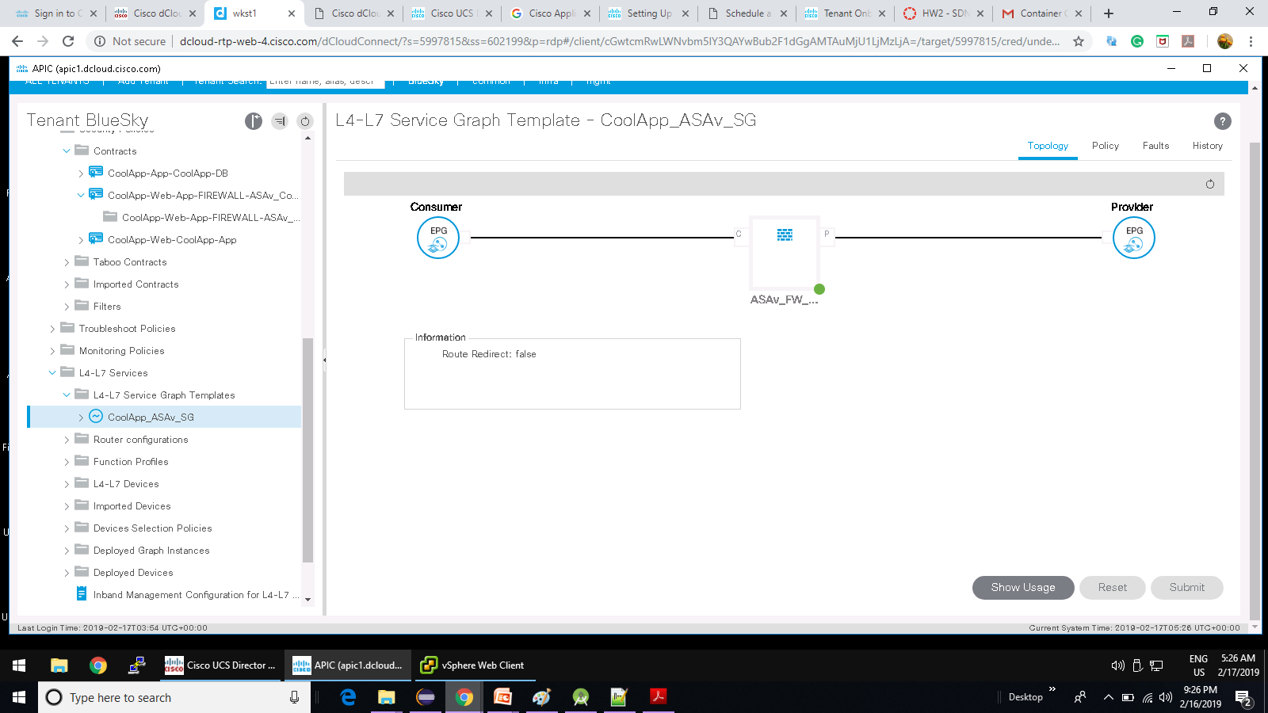

**Scenario 3:** Deploy an Application Container with L4-L7 Services (ASAv) – L4-L7 Devices – CoolApp DC Virtual Firewall

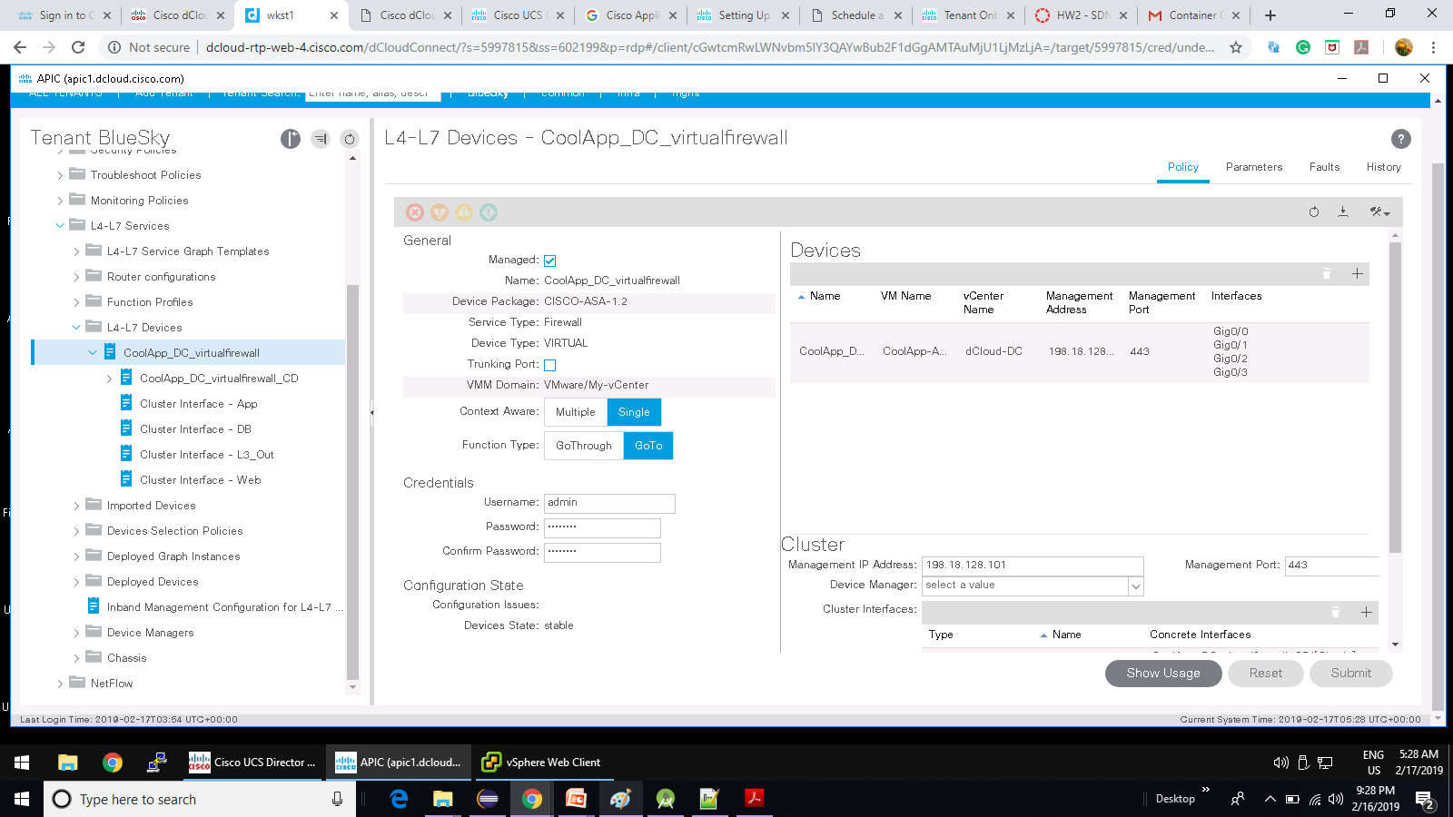

**Scenario 3:** Deploy an Application Container with L4-L7 Services (ASAv) – vSphere Web Client Hardware details

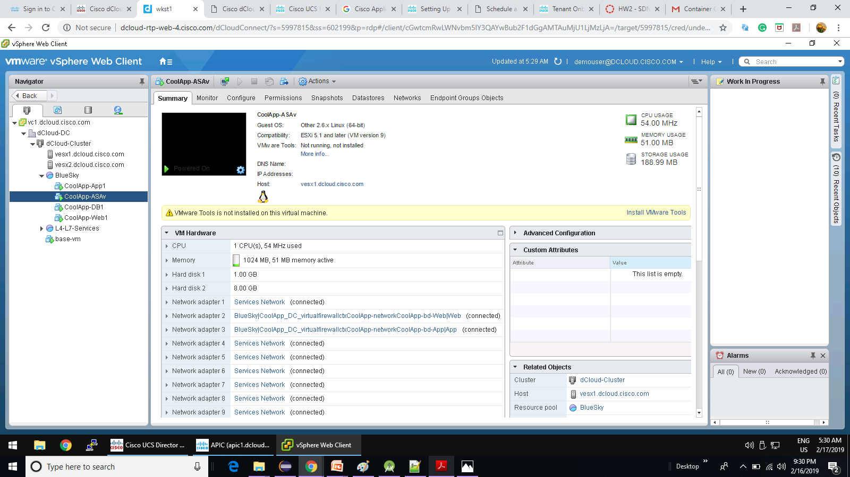

**Scenario 3:** Deploy an Application Container with L4-L7 Services (ASAv) – Cisco ASDM CoolApp firewall creation

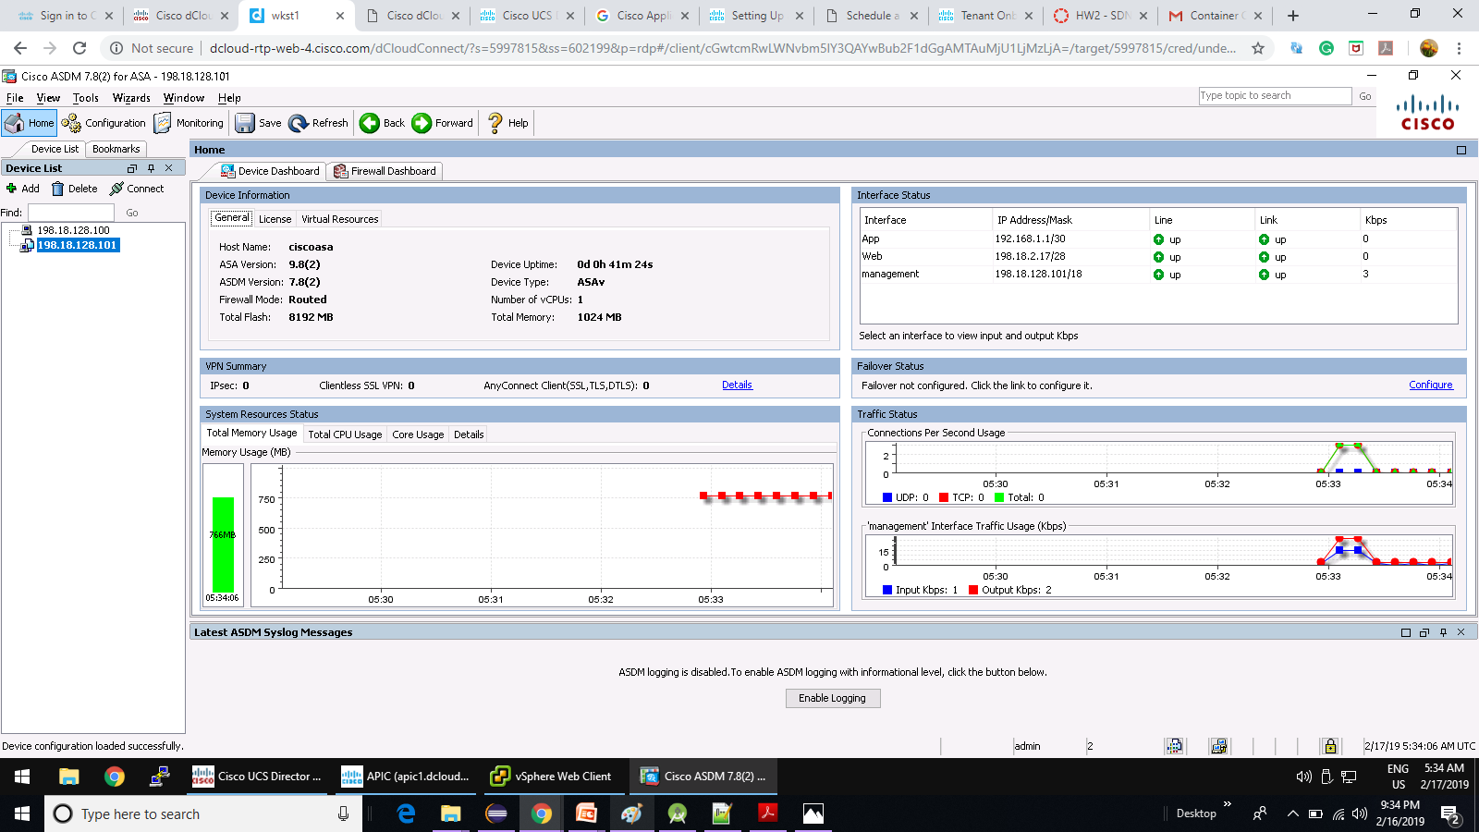

**Scenario 3:** Deploy an Application Container with L4-L7 Services (ASAv) – UCS Director CoolApp Virtual Resources

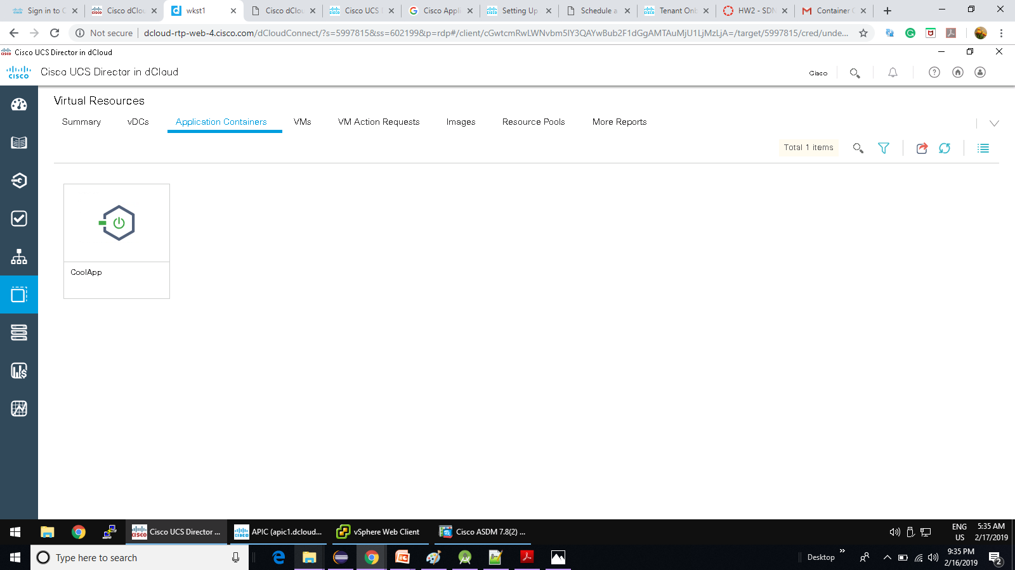

**Scenario 3:** Deploy an Application Container with L4-L7 Services (ASAv) – CoolApp Container creation Email

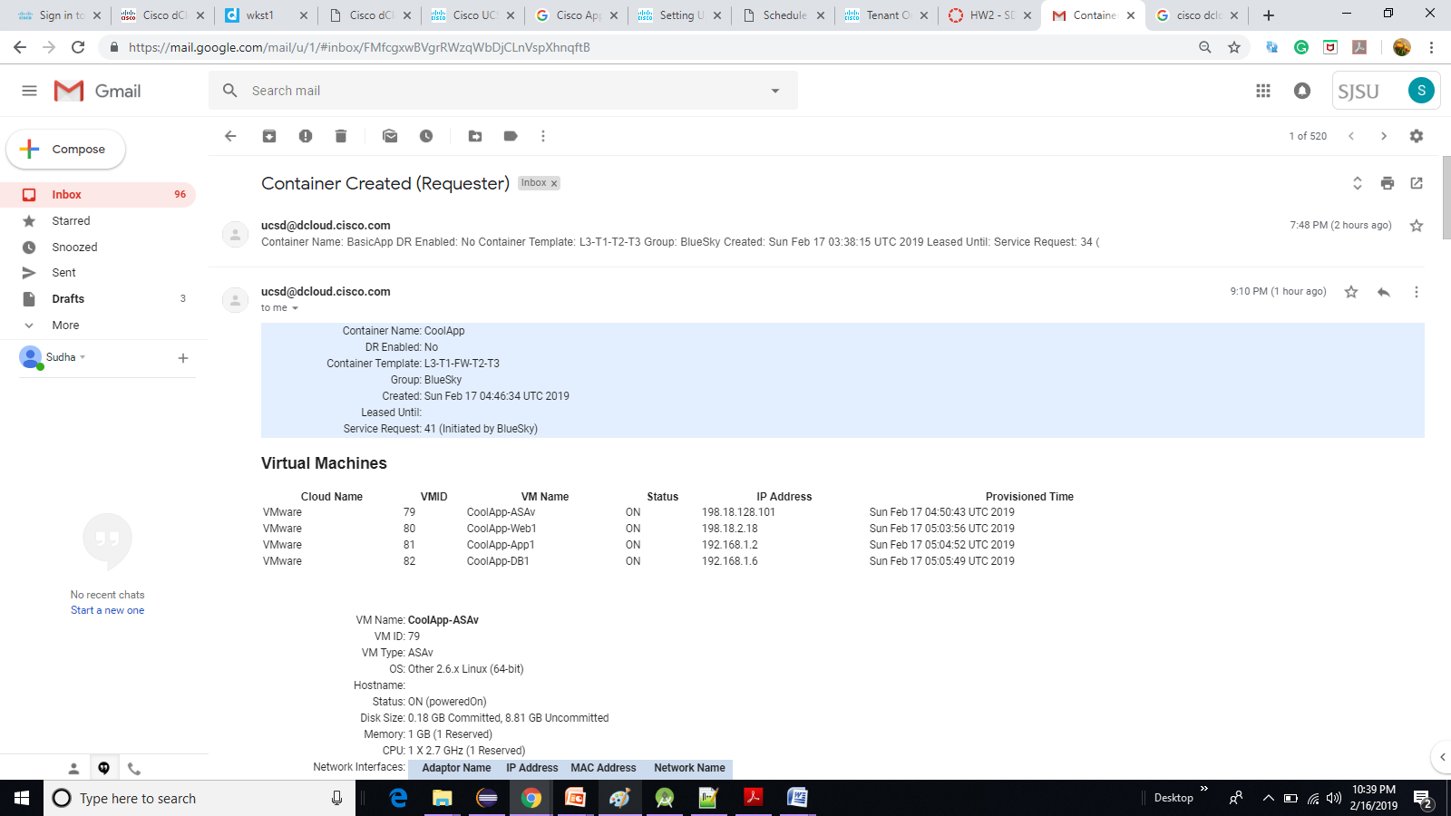

**Scenario 4:** Deploy a 3-Tier Application with L4-L7 Services (Load Balancer)

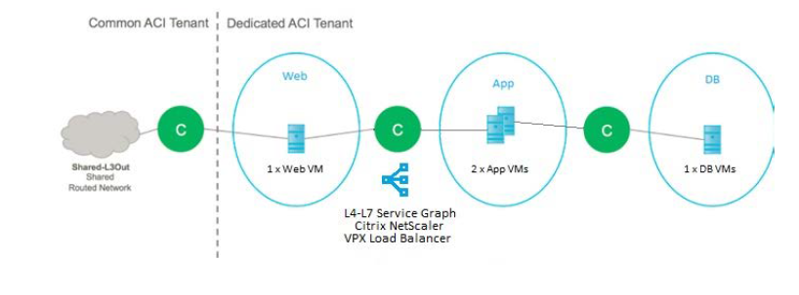

**Scenario 4:** Deploy a 3-Tier Application with L4-L7 Services (Load Balancer) – Workflow

The 3 Tier App L3Out LB workflow performs the following steps:

• Creates a container in UCS Director and allocates resources.

• Creates the APIC objects – Application Profile, private network, Bridge Domains and Contracts. New Port Profiles are automatically propagated to the VMware Distributed Switch.

• Creates the VM for each application in VMware, connecting each to the relevant Port Profile for its tier.

• Creates a child workflow that creates the L4-L7 Configuration (Load Balancer), and attaches it to the already available VPX virtual appliance.

• Sends confirmation email to Tenant Admin Email Address (from Scenario 1).

**Scenario 4:** Deploy a 3-Tier Application with L4-L7 Services (Load Balancer) – Service Request Creation

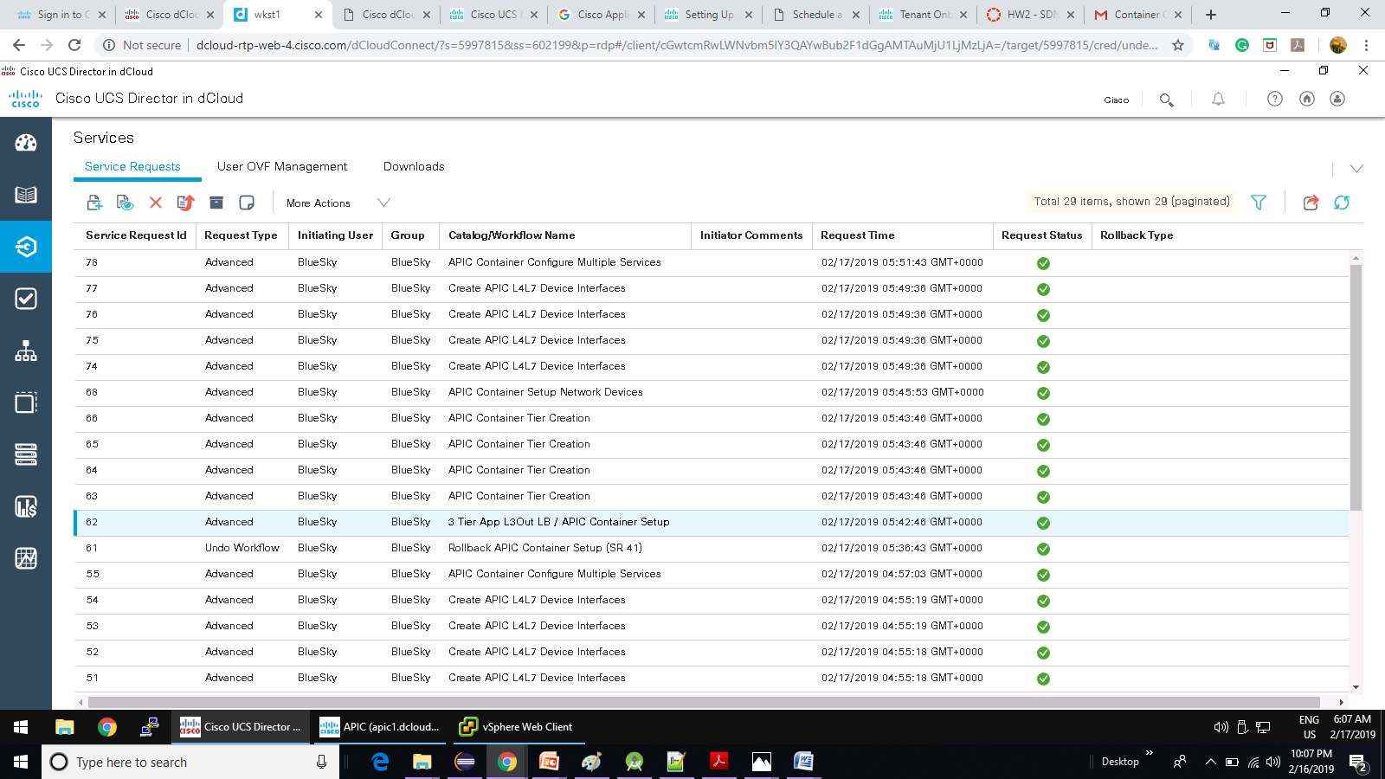

**Scenario 4:** Deploy a 3-Tier Application with L4-L7 Services (Load Balancer) – LBApp Application Profile Topology

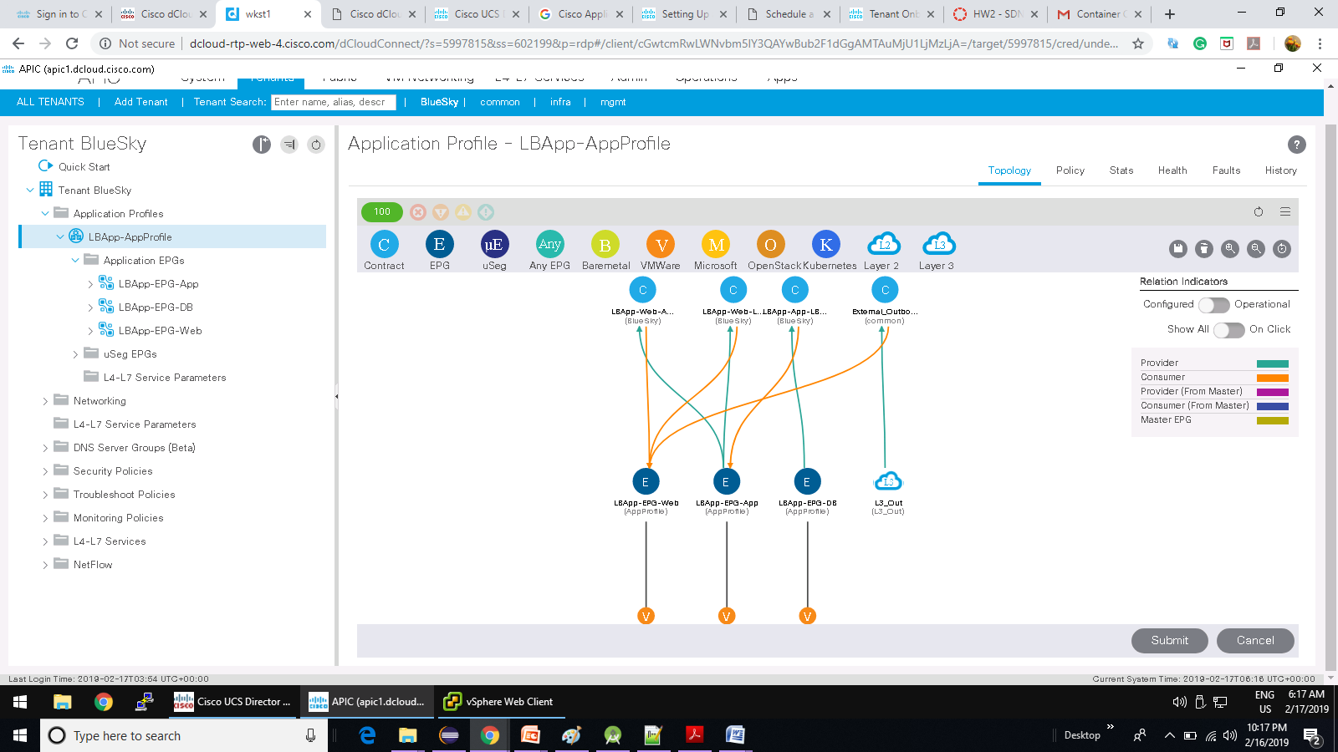

**Scenario 4:** Deploy a 3-Tier Application with L4-L7 Services (Load Balancer) – vSphere Web Client LBApp creation

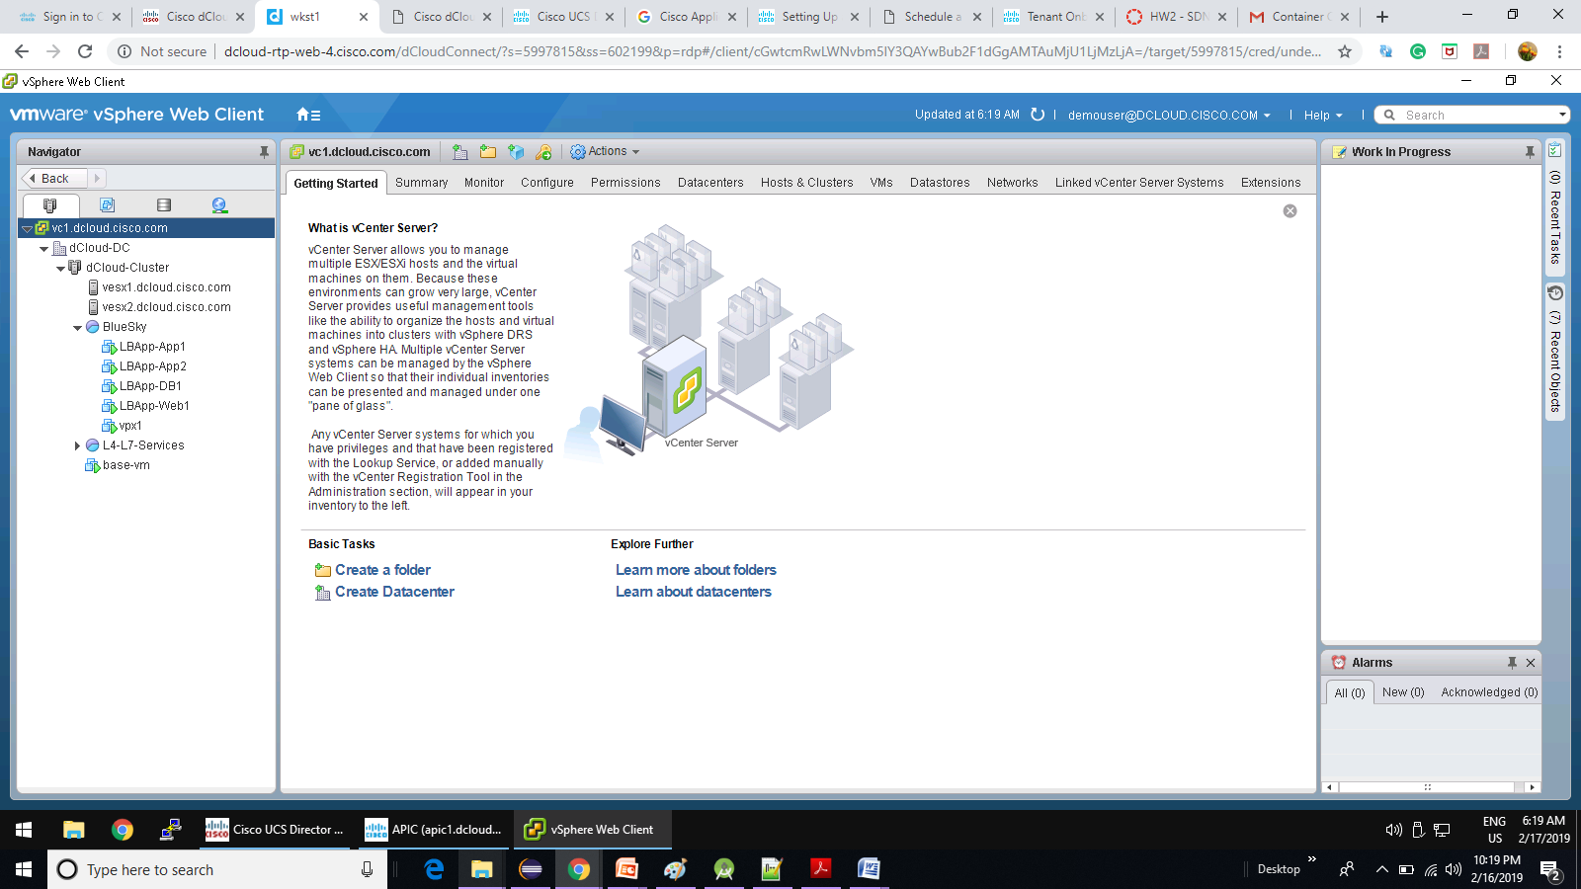

**Scenario 4:** Deploy a 3-Tier Application with L4-L7 Services (Load Balancer) – L4-L7 Service Graph Template for LB_App on APIC

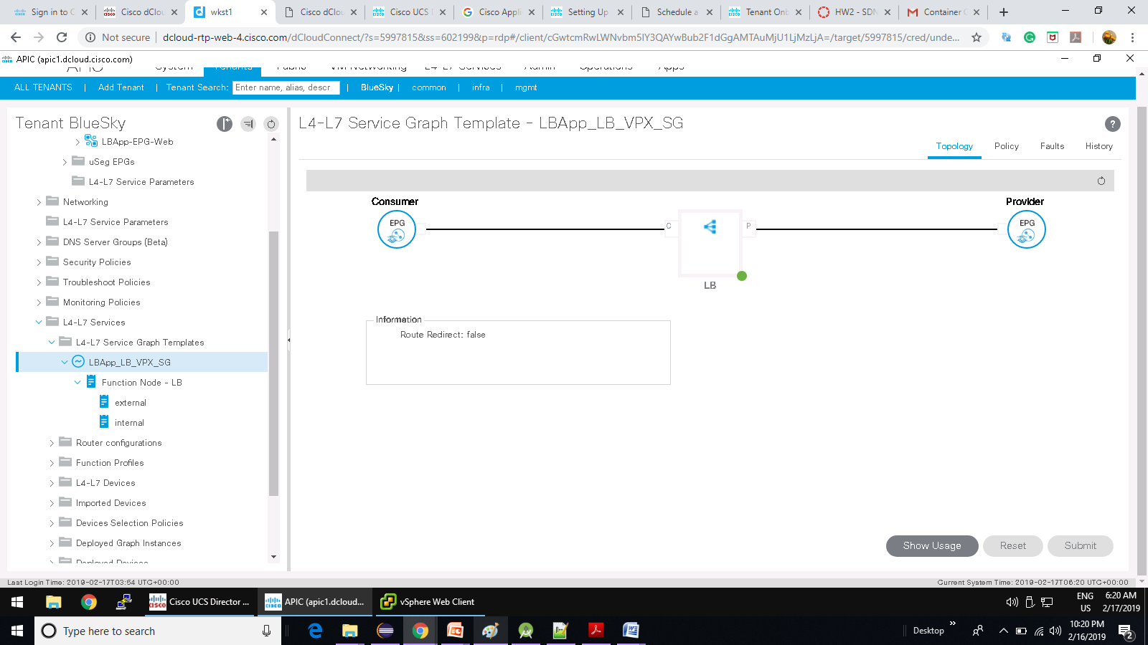

**Scenario 4:** Deploy a 3-Tier Application with L4-L7 Services (Load Balancer) – L4-L7 Devices virtuallb on APIC

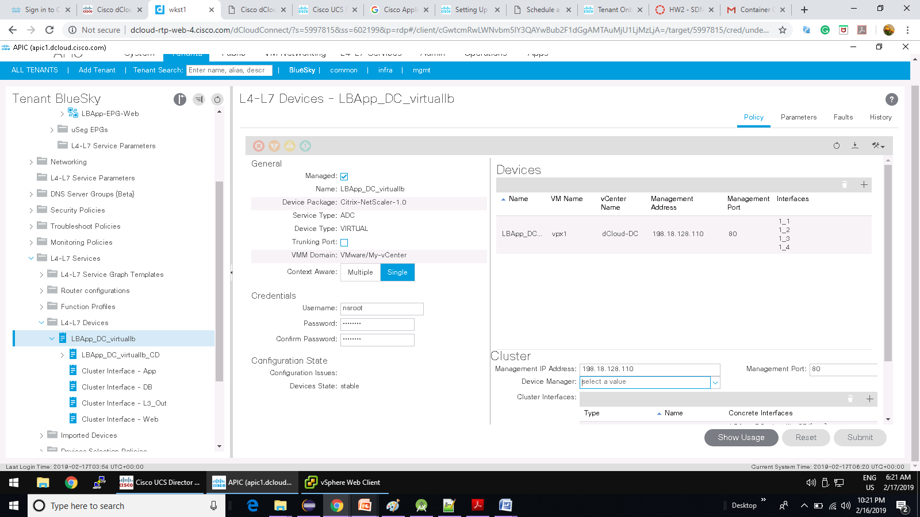

**Scenario 4:** Deploy a 3-Tier Application with L4-L7 Services (Load Balancer) – Deployed Graph instances

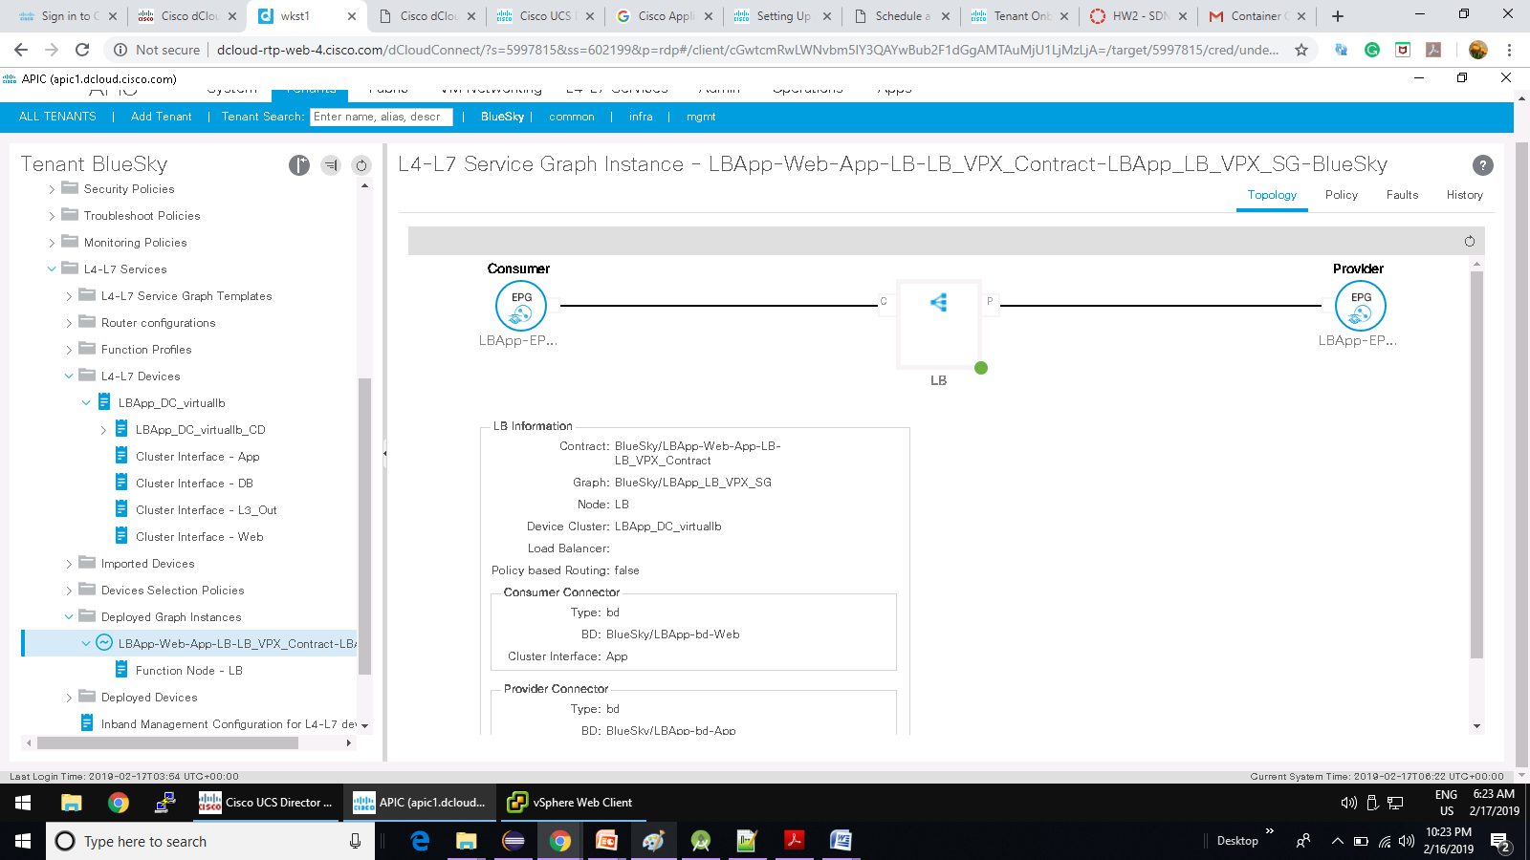

**Scenario 4:** Deploy a 3-Tier Application with L4-L7 Services (Load Balancer) – Deployed devices Virtual Device network

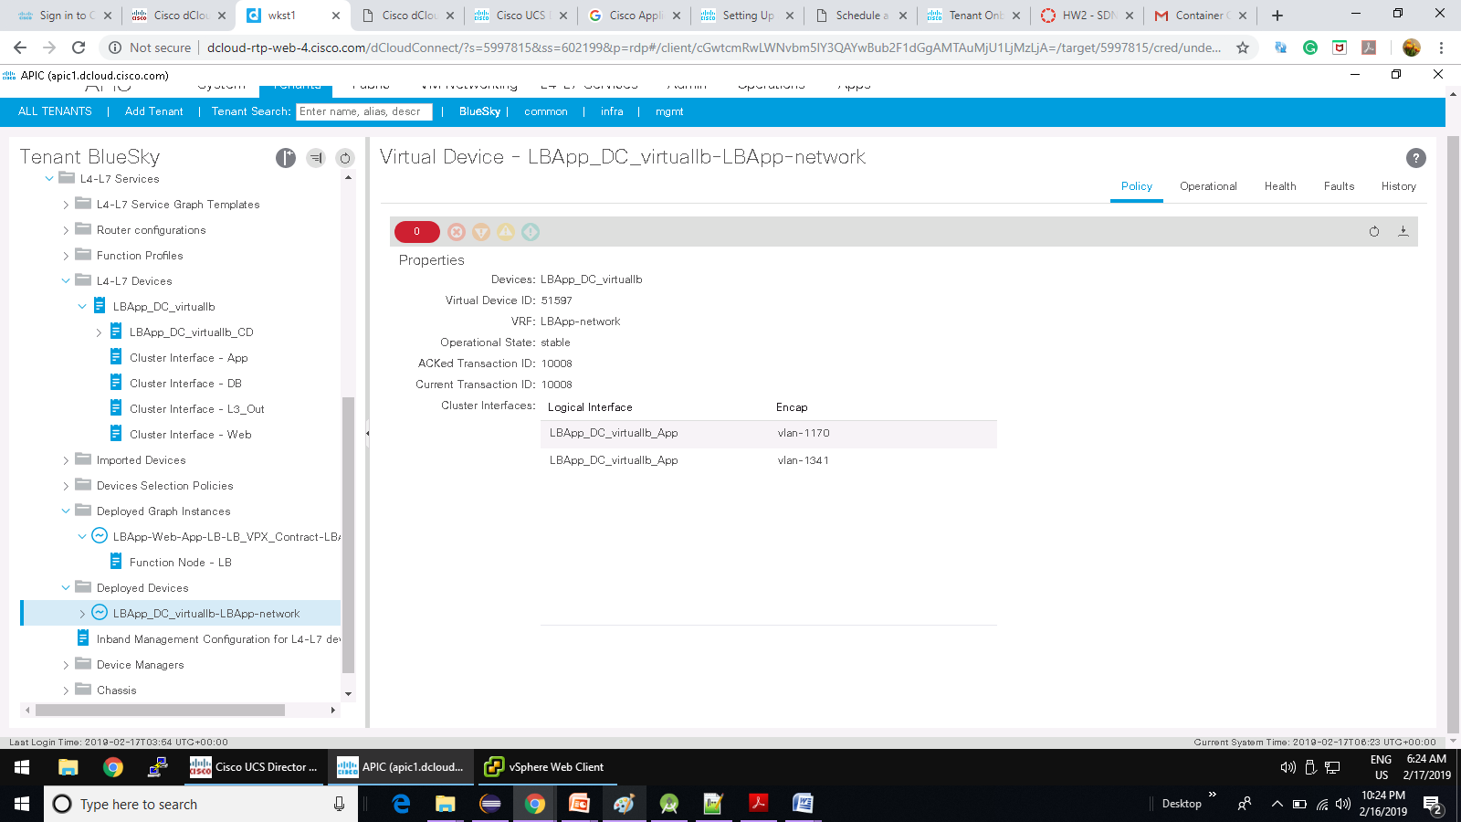

**Scenario 4:** Deploy a 3-Tier Application with L4-L7 Services (Load Balancer) – Citrix Netscaler VPX Virtual Servers

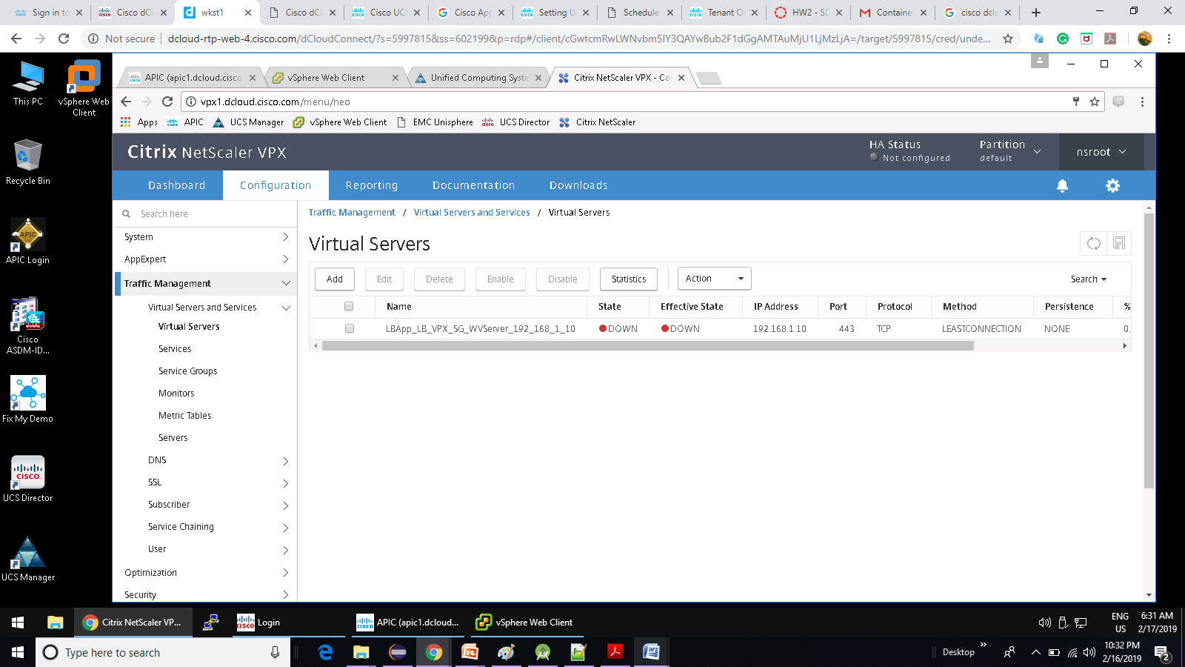

**Scenario 4:** Deploy a 3-Tier Application with L4-L7 Services (Load Balancer) – UCS Director Virtual Resources

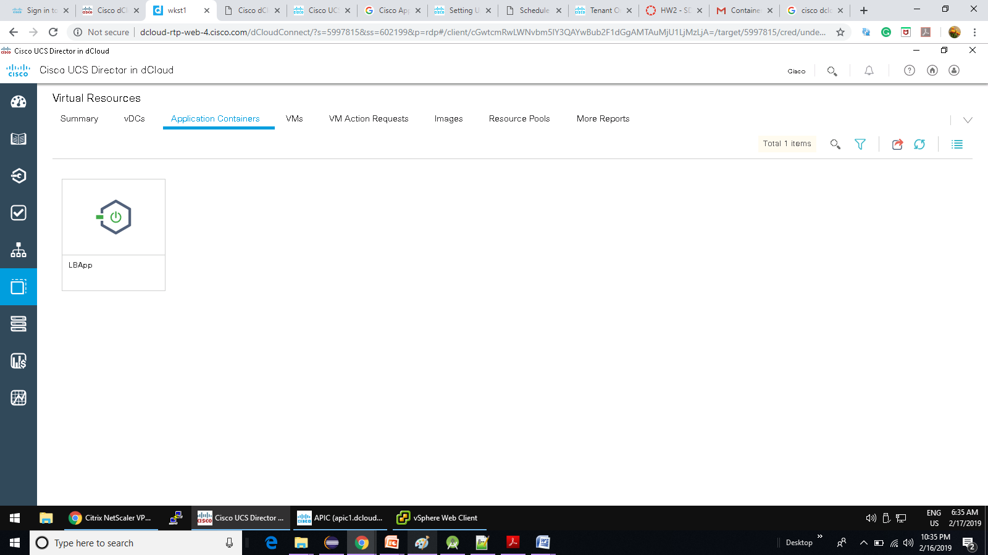

**Scenario 4:** Deploy a 3-Tier Application with L4-L7 Services (Load Balancer) – Container Creation Email for LBApp

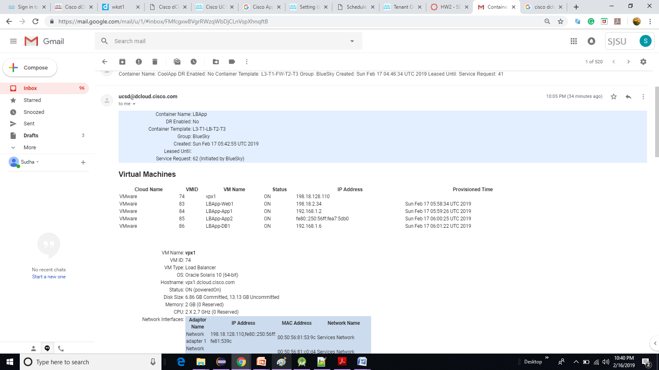

**Scenario 5:** Deploy a 3-Tier Application with a Physical Server (Emulated) – Workflow

The 3 Tier App with VMware and UCS workflow performs the following steps:

• Creates the APIC objects – Application Profile, Bridge Domains, EPGs and private network.

• Creates the VMs for the App and Web tiers in VMware.

• Creates a new Organisation in UCS Manager and also defines the database tier VLAN.

• Deploys a new Service Profile and associates it with a Server Pool, and attaches it to the database tier VLAN.

**Scenario 5:** Deploy a 3-Tier Application with a Physical Server (Emulated) – Service creation of CoolApp

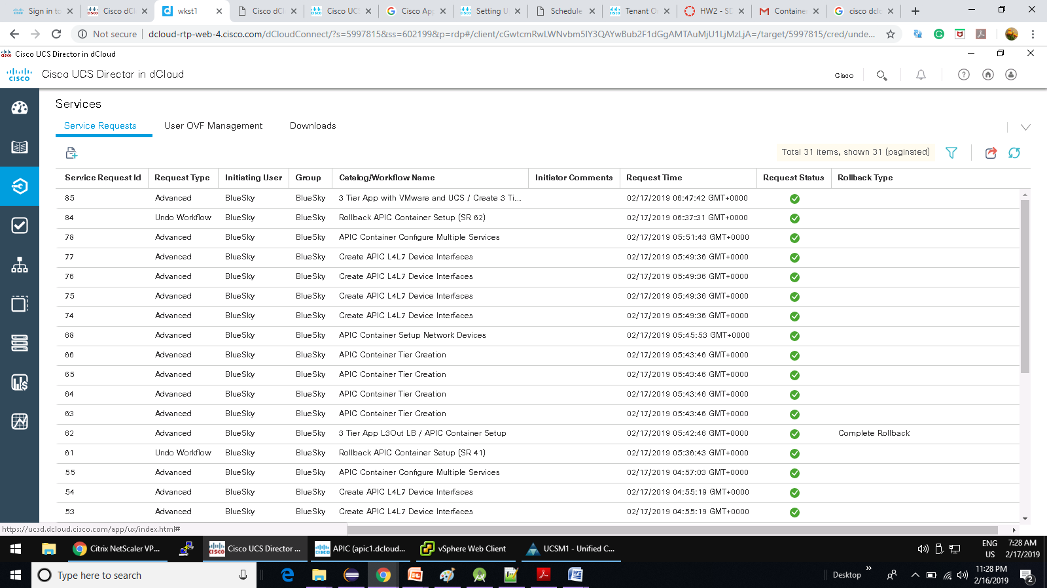

**Scenario 5:** Deploy a 3-Tier Application with a Physical Server (Emulated) – CoolApp Application Profile Topology

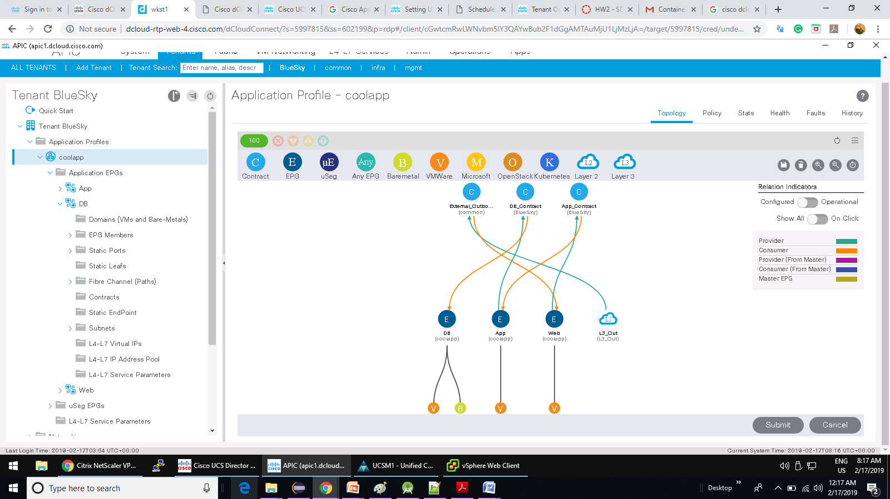

**Scenario 5:** Deploy a 3-Tier Application with a Physical Server (Emulated) – vSphere Web Client HW details

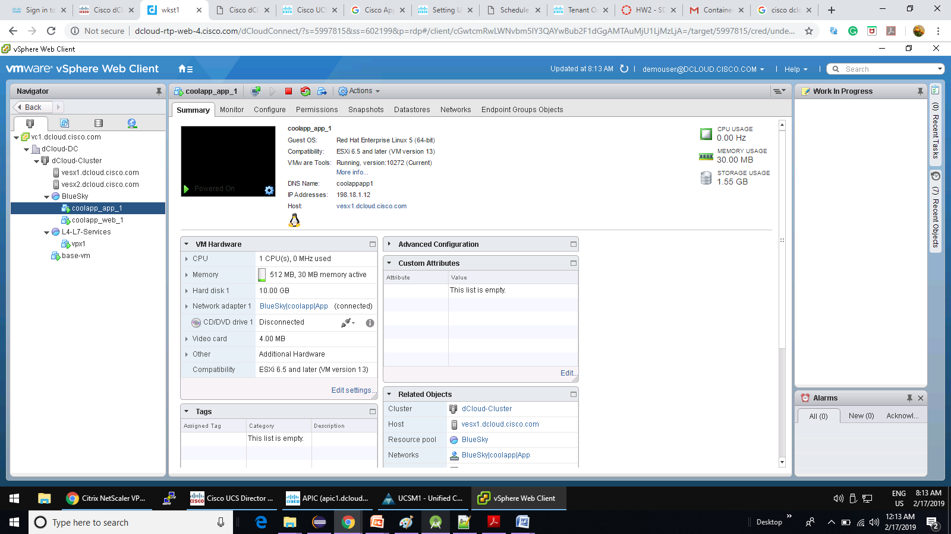

**Scenario 5:** Deploy a 3-Tier Application with a Physical Server (Emulated) – Service Policy Contracts

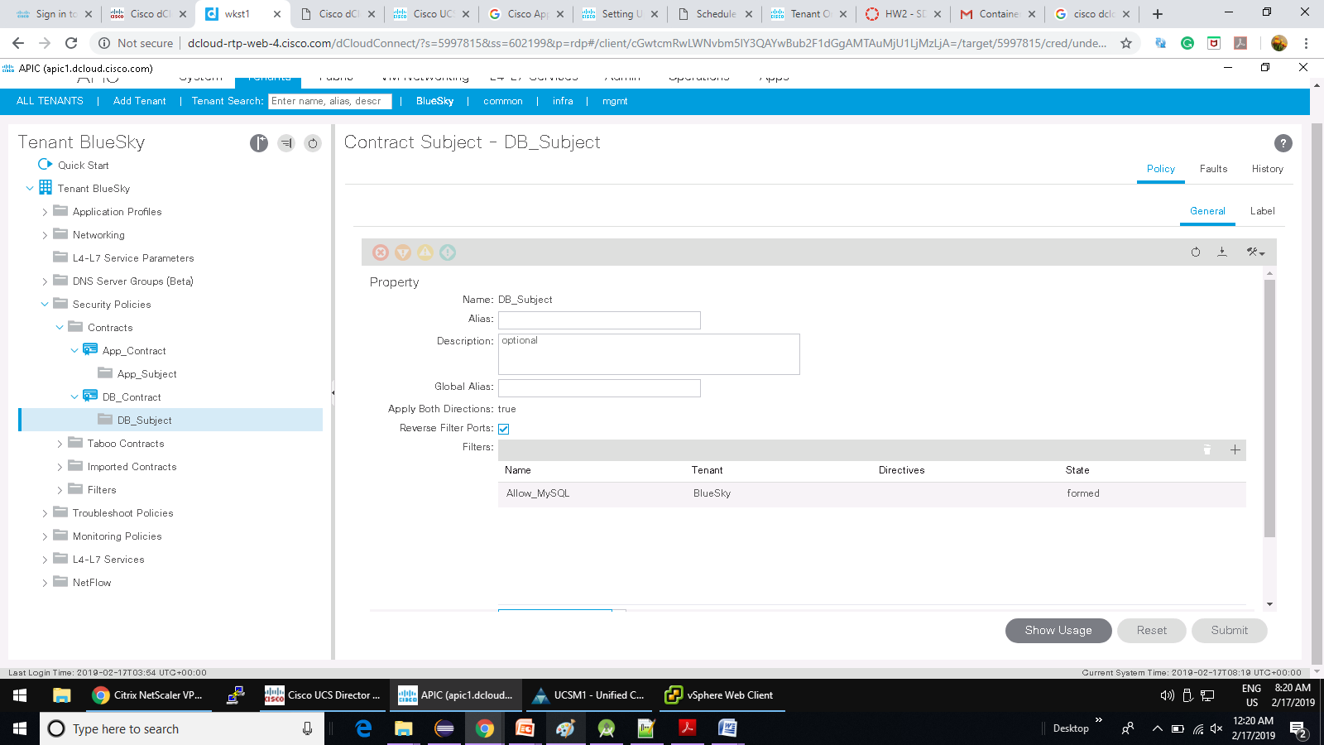

**Scenario 5:** Deploy a 3-Tier Application with a Physical Server (Emulated) – UCS Manager VLAN profiles

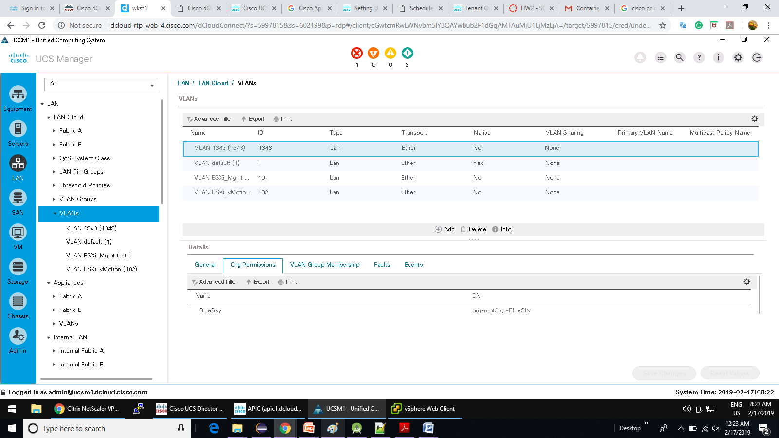

**Scenario 5:** Deploy a 3-Tier Application with a Physical Server (Emulated) – UCS Manager – Corresponding VLANS set in vNICs by the Servers CoolApp

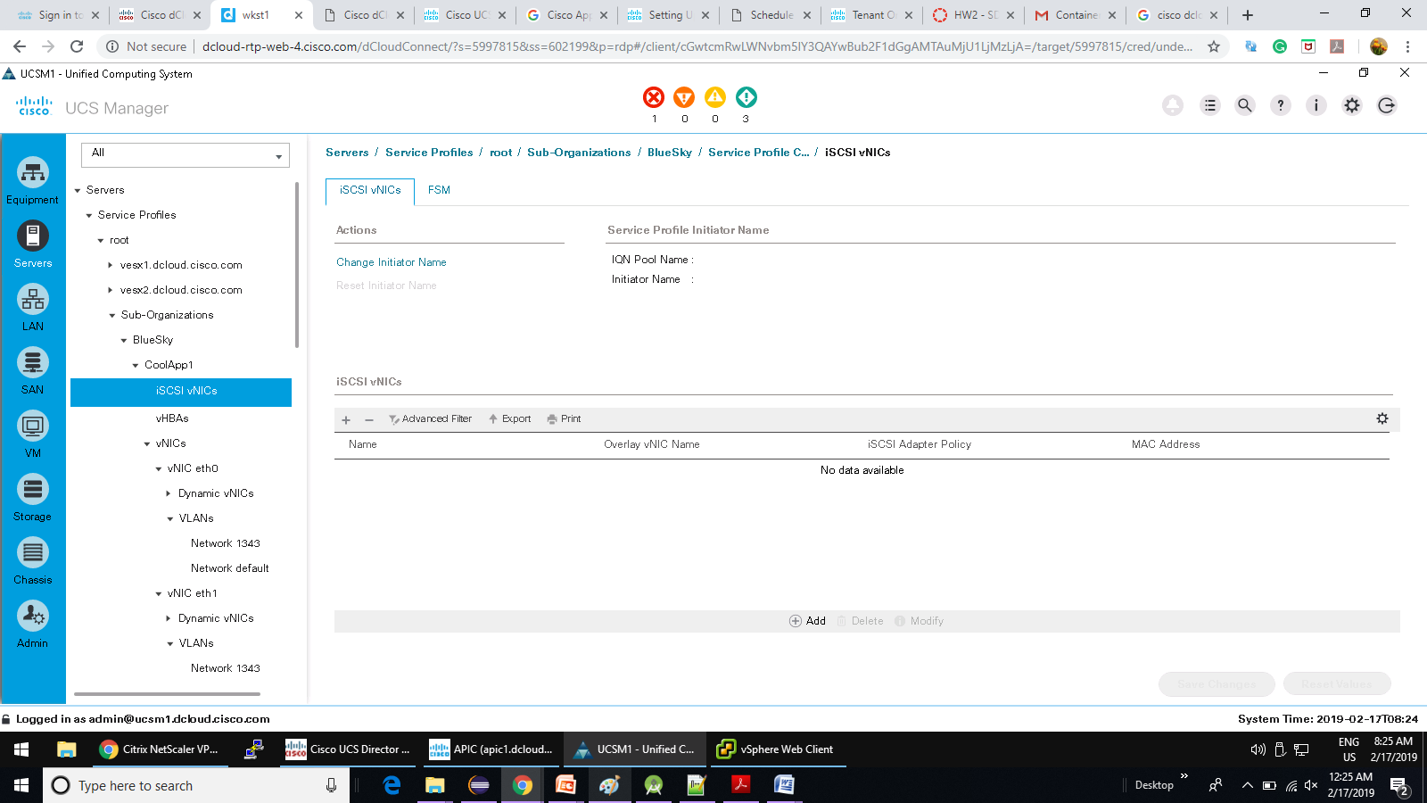

**Scenario 5:** Deploy a 3-Tier Application with a Physical Server (Emulated) – Servers CoolApp Service Profile

